

Maynooth Educate Together National School

Supporting Children with Additional Educational Needs Policy

2025

Contents:
Table of Contents
Contents: 2
Introduction 3
1. Context 4
2. Inclusive Education 4
3. Aims of Special Education Support 4
4. The Continuum of Support 4
5. Student Support Plan 6
6. Staff Roles and Responsibilities 7
7. Procedure for Identifying Students Requiring Support 12
8. Support Teaching 13
9. Tracking and Recording 14
10. Record Keeping 14
11. Continuing/Discontinuing Support Teaching 14
12. Parental /Guardian Engagement 14
13. Timetabling 15
14. Continuous Professional Development (CPD) /Teacher Professional Learning (TPL) 15
15. Supporting Transitions 15
Transitions have been identified as a significant risk factor to the wellbeing of children with Special Education Needs. Children with SEN should ideally be identified two years prior to the date on which the child is due to transfer from the school. These transitions should be supported by the principal, deputy principal, SET and class teachers. 15
16. Reviewing this Policy 15
Appendix 1 Student Support File 16
Appendix 2 Pupil Care Plan………………………………………………………………………………………………………….21
Appendix 3 SEN School Provision Plan 22
Appendix 4 Target Setting Problem Solving approach………………………………………………………………….24
Appendix 5 Solution Focused Behaviour Plan 25
Appendix 6 Steps to Follow COS 27
Appendix 7 Annual Confirmation to the Board-deployment of SET resources…………….…………………29
Appendix 8 Basic Needs Checklist…………………………………………………………………………………………………30
Appendix 9 Learning Environment Checklist 31
Appendix 10 My Thoughts About School Checklist 34
Appendix 11 Assessments available in the school……………………………………………………………………… 36
Appendix 12 SEN Yearly Schedule……………………………………………………………………………………………….39
Appendix 13 Schedule of Deployment of SETs for Children with SEN ……………………..……...............40
Appendix 14 Differentiation……………………………………………………………………………………………………...41
Appendix 15 Glossary of Terms………………………………………………………………………………………………….42

Introduction
This review of the Policy to Support children with Additional Educational Needs was carried out by the Board of Management, parents/guardians and staff of Maynooth Educate Together NS. The policy takes cognisance of directives contained in the Education Act (1998), the EPSEN Act (2004), Guidelines for Primary Schools Supporting Pupils with Special Educational Needs in Mainstream Schools (DES 2024), Circular 0013/2017 (DES, 2017) the Learning Support Guidelines (DES, 2000), the Special Educational Needs-A Continuum of Support Resource Pack for Teachers (2007), English as an Additional Language in Irish Primary Schools-Guidelines for Teachers (2006), The Special Needs Assistant (SNA) scheme to support teachers in meeting the care needs of some children with special educational needs arising from a disability (circular 0030/2014), Behavioural, Emotional and Social Difficulties, A Continuum of Support, Guidelines for Teachers (2010 NEPS) and Guidelines for Primary Schools Supporting Children with Special Education Needs in Mainstream Classes 2024)
Monitoring and review of this policy is ongoing as the school’s profile changes from year to year.

The Special Education Teaching (SET) Allocation provided to schools is an additional resource, which is ring fenced for the sole purpose of providing additional support to children whom the school has identified, through the problem-solving process as having Special Educational Needs (Guidelines for Primary Schools Supporting Children with Special Education Needs in Mainstream Classes 2024)

METNS has two Autism classes which enable autistic students and those with more complex special educational needs to be educated, in smaller groups, within the school. They offer a supportive learning environment to students who are unable to access the curriculum in a mainstream class on a full-time basis, even with support, for most or all of their school day. Integration within the mainstream setting is encouraged and supported, as appropriate for each child and with the best interests of each child being prioritised.

Principles underpinning the special education teaching model
These principles provide the basis for schools to guide the implementation and ongoing development of their systems, structures, practices and policies to support the inclusion of all children, including those identified with special education needs.

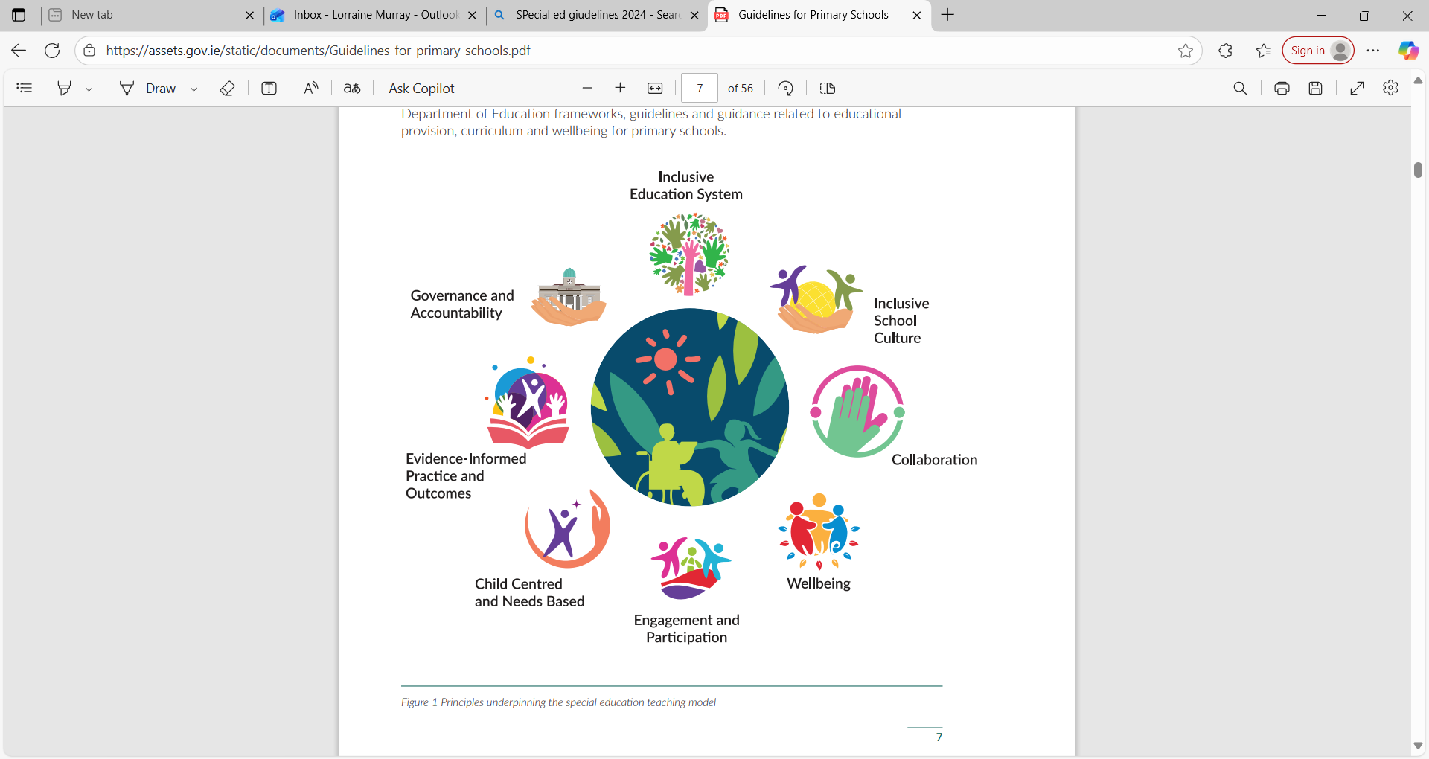

Context

Maynooth Educate Together National School (METNS) is a co-educational school, catering for students from Junior infants – 6th Class. The school has two classes for autistic children. Our current enrolment is 415 children.

2. Inclusive Education

At METNS, we have adopted a whole-school approach to inclusion. An inclusive education system is one that recognises and celebrates diversity and this includes neurodiversity. Neurodiversity means that not all children experience the world in the same way. It emphasises the importance of respecting, valuing and celebrating such differences. A positive ethos and learning environment are encouraged, whereby all students feel welcome and experience a sense of community and belonging. The school community promotes the active engagement of each student in their learning and in the life of the school. There is a commitment to developing students’ academic, social, emotional and independent living skills coupled with a focus on high aspirations and improving learning outcomes for all.

3. Aims of Special Education Support

(i)To promote inclusion of and provide support to students identified as needing additional supports to access education by offering appropriate forms of education provision and the most efficient use of available resources.
(ii) To identify pupils needing additional supports to access education as early and as thoroughly as possible using a variety of means and in consultation with appropriate personnel and to support these pupils by prioritising the children with the greatest level of need at the outset.

4. The Continuum of Support

At METNS, we employ a staged approach to supporting students. The NEPS (National Education Psychological Service) Special Educational Needs Continuum of Support provides a structure for this. The Department of Education and Youth follows best practice in ensuring that all children with Special Education Needs are provided with an education appropriate to their needs. The support can range from transient to enduring over their time in primary school. Using the Continuum of Support, helps to ensure flexible and timely allocation of supports, so that those children with the greatest level of need have access to the greatest level of support.

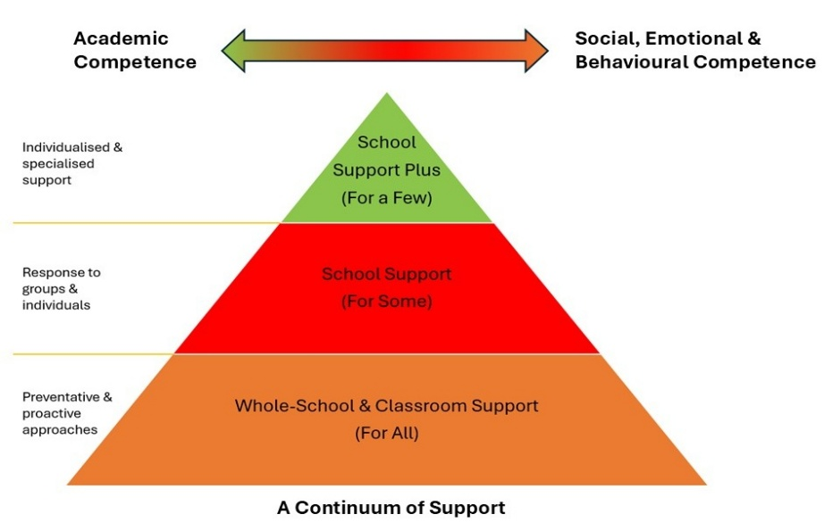

Stage 1: Classroom Support (Support for All)
In order to proactively support students, a number of interventions are in place to address additional needs in the areas of numeracy, literacy, social and emotional learning and development, motor skills and English language development/English as an additional Language. Such interventions include:
- UDL – Universal Design for Leaning -differentiation by product, instruction, resource, support and time given to complete tasks.
- In Class Support Teaching within the mainstream classrooms.
- Specific class-based programmes.
- School designed initiatives focusing on different areas.
Where specific concerns remain regarding a student’s learning or social development, following engagement with some of the above interventions, the classroom teacher in consultation with the SET (Special Education Teacher) and SENCO (Special Education Needs Co-ordinator) will arrange to meet with parents/guardians. At this meeting, a Classroom Support Checklist will be completed. This will be used to inform the next stage of the process. The Student Support Plan will be opened at the Classroom Support stage. Depending on the need, an individualised Classroom Support Plan is devised or, if appropriate, the student will move to….

Stage II (School Support) of the Continuum of Support.
Stage II: School Support (Support for Some) If intervention is considered necessary at Stage II, then the student will be referred to the SET, with parents/guardian’s permission, for further assessment and/or diagnostic testing. If this assessment suggests that support teaching would be beneficial, this will be arranged. The parents/guardians and the classroom teacher will be involved with the SET in drawing up the School Support Plan which will include appropriate interventions for implementation in the home, in the classroom and during support teaching. After an agreed period of time, the SET and the classroom teacher, in consultation with parents/guardians, will review the rate of progress of each student receiving support teaching. If significant concerns remain, then it may be necessary to provide interventions at Stage III. In the case of students with emotional or behavioural difficulties it is recognised that, in certain circumstances, more urgent action may be required. In these cases, the student’s needs will, with parents/guardian’s permission, be discussed with the relevant NEPS psychologist and/or the case will be referred to the clinical services of the Health Services Executive. This may lead to a developing a personalised support plan with helpful strategies for home and school environments or to a referral for further specialised assessment.
Stage III: School Support Plus (Support for a few)
Some students who continue to present with significant learning needs will require more intensive intervention at Stage III. The school may formally request a consultation and, where appropriate, an assessment of need from a specialist outside the school in respect of students with learning differences or who are experiencing challenges with co-regulation and self-regulation and have not made progress at Stage II. Such specialist advice may be sought from psychologists, paediatricians, speech and language therapists, audiologists, etc. The classroom teacher and the SET, in consultation with the relevant specialist(s), will then draw up a learning programme that includes identification of any additional resources that are considered necessary in order to implement the programme. The parents/guardians will be fully consulted with throughout this process. This programme will be the subject of regular reviews, leading to revisions of the learning programme and referral for specialist review, as necessary.

5. Student Support Plan

When a teacher or parent/guardian expresses concern about a student, a Student Support File may be opened via Teams at Stage I of the Continuum of Support. The Student Support File allows the school to track the student’s pathway through the Continuum of Support – from the start of the support process, and onwards if necessary, through to School Support (for some) and School Support Plus (for a few). Contents of the Student Support Plan include: a. Student details b. Results of standardised and diagnostic tests c. Log of actions d. Support checklist e. School Support Plan (See section 5.1) and f. Support Review. Only relevant staff will have access to the support files, namely; the class teacher, associated SET(s), SENCO and Principal will have access to the support files.

(i)School Support Plan (SSP) Record
At the beginning of a term of support teaching, planning will be based on the individual needs of the student. Once support teaching has begun, the records and assessment of support teaching sessions are used as a basis for on-going planning, teaching, learning and assessment. The SSP is the responsibility of the class teacher. It is written in consultation with the SET and parents/guardians. The SSP is used to record relevant information relating to a student’s learning attainments and his/her learning strengths and needs. Any SSPs pertaining to students with SNA access must include a care plan. The latter is prepared by the class teacher and SNA working with the child.
METNS adopts an inclusive approach to the education of children with special educational and additional needs. This means that the student, his/her classroom teacher, parents/guardians, the Special Education Teacher (SET), the SNA (where appropriate) and the school principal along with any other relevant people such as educational psychologists, occupational and language therapists are included in the process, where practicable. SSPs are put in place for existing students in October. SSPs are put in place for new junior infants by end of October of the current school year. All SSPs will be reviewed in February of the following year. The SSP includes: a. Student details, b. Student’s strengths and interests, c. Priority concerns, d. Possible reasons for concerns/Impact of SEN and or EAL on educational development, e. Targets for the student, f. Strategies to help student achieve the targets, g. Staff involved and resources needed, h. Signatures of parents/guardians and teachers, i. Care plan (students with SNA access). Children who need support with emotional regulation, sensory needs, or co-regulation may have an Individual support plan added to the SSP if needed.
Student Surveys are important to identify the student’s strengths, interests and needs. Interventions to address identified needs should be considered in the context of the child’s strengths and interests. Student Support Plus Plans should include targets that are aligned to the identified priority needs of the children.

6. Staff Roles and Responsibilities

Supporting learning is the collaborative responsibility of all. It is envisaged that the Board of Management, principal teacher, classroom teachers, Special Education Teachers, SNAs, parents/guardians and children will all contribute to the development and implementation of the school’s policy on Inclusive and Special Education.

(i) The Board of Management
The Board of Management has an important role in developing, supporting and monitoring school policy on Inclusive and Special Education. The Board of Management will discharge this responsibility as per Learning Support Guidelines (2000) and the Education Act (1998). The Board of Management shall:
- Ensure that it receives annual confirmation from the principal on the use of special education teaching resources (See appendix 13)
- Oversee the development, implementation and review of the Inclusive and Special Education Policy.
- Ensure as far as is practicable, that adequate classroom accommodation and teaching resources are provided for Special Education Teachers and their pupils.
- Provide a secure facility for storage of records relating to students in receipt of Special Education Support until the student reaches the age of twenty-five.

(ii) The Principal Teacher
The school principal has a primary role in modelling, promoting and building whole school staff capacity to maintain effective inclusion practice throughout the school.
The principal has overall responsibility for the school’s learning support programme and for the operation of services for children with special educational needs. (Learning Support Guidelines p. 38). The Education Act (1998) and the EPSEN Act (2004) have all reiterated this responsibility. In METNS, the principal teacher:
• Assumes overall responsibility for the development and implementation of the school’s policy on Inclusive and Special Education in co-operation with the classroom teachers and SETs.
• Monitors the implementation of the school policy on Inclusive and Special Education on an ongoing basis.
• Monitors the identification of students for support teaching and ensures that the children with the greatest levels of need have access to the greatest levels of support.
• Oversees the implementation of a whole-school assessment and screening programme to identify students with special educational and additional needs so that these students can be provided with the support they need.
• Encourages and facilitates continuous professional development (CPD) of the staff to increase their knowledge and skills in the area of inclusive and special education.
• Informs teachers about the external assessment services that are available and the procedures to be followed for initial referrals.
• It is considered best practice for the principal to meet with the SET team regularly to review progress and implementation of the policy (meetings will be typically held during the months of October, February and May).

(iii) The Special Education Needs Co-ordinator (SENCO) The Deputy Principal currently fills the role of co-ordinating inclusive and special education in METNS. The co-ordinator oversees the day-to-day operation of the support teaching programme, however final responsibility rests with the principal.
The Co-ordinator of Special Education:
• Maintains a list of students who are in receipt of special education (register).
• Helps to co-ordinate the caseloads and work schedules of the Special Education Teachers and SNAs.
• Liaises with external agencies such as NEPS, HSE, CAMHS, SCPA, Private SLTs/OTs/Play therapists and Clinical Psychologists to arrange assessments, reviews and referrals.
• Liaises with parents/guardians and organises consultations and appointments with support agencies.
• Liaises specifically with NCSE in relation to the acquisition of assistive technology, SNA assistance, CPD, visiting teacher support etc.
• Liaises with the staff of local second level schools in relation to transfer of documentation/reports pertaining to students at transfer.
.Promotes CPD amongst all staff in the area of Special Educational Needs and Inclusion and commits to developing one’s own professional development in this area
• Aids the completion of the process of application for exemption from Irish in accordance with Circular 0054/22.
• Is responsible for the purchase of materials and resources used by SETs.
• Is responsible for standardised testing in the school by facilitating testing which includes the supply of materials, timetabling, and directing correction.
• Ensures that all members of staff are familiar with and adopt the staged approach to the Continuum of Support.

(iv) The Classroom Teacher
•Has primary responsibility for the education, progress and care of all students in his/her classroom, including students with special educational and additional needs. It is the responsibility of the classroom teacher to ensure that each student is taught in a stimulating and supportive classroom environment where all students feel equal and valued.
• May gather information through formal and informal means, in line with Continuum of Support Guidelines, with a view to informing interventions. In particular the classroom teacher has responsibility for initiating the Continuum of Support in consultation with the SET and parents.
• Has primary responsibility for the compilation of the SSPs for children in their care.
• Will make specific accommodations and develop a programme of differentiated instruction for students who present with challenges in the areas of academic progression, EAL, application, communication, behaviour or interaction with peers and will differentiate for the exceptionally able pupil
• Has a central role in identifying and responding to students with additional educational needs, including differentiating the curriculum as appropriate (Universal Design for Learning-UDL). These responses will be informed and assisted in collaboration with colleagues, parents/guardians and others such as the school’s NEPS psychologist, and the school Special Educational Needs Organiser (SENO).
- Avails of develop capacity, knowledge and understanding of Special Education Needs.
- Uses a variety of appropriate methodologies, activities, experiences and materials to cater for children’s individual needs and to create a stimulating and supportive classroom environment.
- Identify children’s strengths, interests and priority learning needs to inform planning, implementation and assessment and regular review of intervention at each level of the Continuum.
- Recording all actions in the Log of Actions and keeping copies of the Classroom Support Plan in the Student Support File

(v) Support Teacher (SET/EAL Combined)
Support teachers will be familiar with a wide range of teaching approaches, methodologies and resources to cater for particular learning styles and to meet a variety of needs. Depending on the learning needs identified, a student with additional educational may be supported at classroom level through a variety of co-teaching approaches or, alternatively, through withdrawal support models. Students may receive support one-to-one or in small groups in or outside the classroom. The Support Teacher will regularly consult with both the classroom teacher and parents/guardians throughout the Continuum of Support. In implementing the School Support Plan, the Support Teacher will:
- Consult with parents/guardians, in conjunction with the classroom teacher, and obtain written permission for inclusion in support teaching by withdrawal and for any diagnostic testing that may be required.
- Consult with the pupils as the views of pupils are central to all matters that affect them. Pupils are involved in identifying their own strengths and needs and in setting learning targets, where possible.

- Collaborate with the classroom teacher in the maintenance of a School Support Plan (SSP) for each student who is selected for support teaching.
- Maintain a monthly record (Cúntas Míosúil) of work for each individual or group of students in receipt of support teaching through withdrawal and will maintain short term plans for each individual or group in receipt of support teaching.
- Collaboratively create a co-teaching plan with the classroom teacher.
- Liaise with the Special Education Co-ordinator to arrange special provision for students with special educational and additional needs.
- Administer a range of formal and informal assessments and maintain records of the outcome of those assessments which are used to inform planning.
- Co-ordinate the implementation of the identification procedure for support teaching as detailed in this policy.
- Contribute to the review and development of the policy for Inclusive and Special Education at whole school level.
- Contribute at school level to decision making regarding the purchase of learning resources, books and materials. Responsibility for the purchase of materials rests with the Special Education Co-ordinator.
- Will commit to undertaking TPL in specific areas as required in order to meet the needs of the pupils they support
- Reflecting on individual professional practice including teaching and learning approaches to enhance provision.
- Preparing and planning on a weekly basis in order to address each child’s specific needs as reflected in support plan targets.
- Will use the pupil survey to identify the child’s strengths, interests and needs.
- Each special education teacher is responsible for leading the development, implementation and review of Student Support Plans for the children with whom they are involved in providing direct additional teaching support

(V.1) Role of the Support Teacher in supporting pupils with EAL
Not all children with EAL will need to access EAL support specifically. PSAK testing, close observations, consultation with class teacher and parents along with other informal assessments will determine which pupils need support from the support team. The support may be provided in the classroom or in a separate learning space, depending on what works best for the students’ needs and targets. The class teacher and support teacher should work collaboratively to ensure that children with EAL acquire the most appropriate language to help them access the curriculum e.g.-language of maths, language of stay safe, language to enable them to have their needs met etc. All support teachers meet the needs of Special Education and EAL as the needs arise across the school.

(v.2) Role of the Special Education Teacher in the Autism Classes

The Autism Class Teacher helps to provide an education which meets the needs and abilities of children assessed as Autism diagnosis and/or Complex Needs. The Autism Class will have a ratio of 6 pupils to 1 teacher and 2 Special Needs Assistants. This teacher will advise and liaise with other teachers, parents/guardians and other professionals in the pupil’s interests.
More specifically, the Autism Class Teacher has responsibility for:
- Being the main point of contact for the child’s parents/guardians.
- Involving parents/guardians in the educational process, e.g. School Support Plan, Additional Care Needs Plan
- Regular Communication. Liaising with other staff working with the child. Initiating a review of that and organising venue, date and time to consult with parents/guardians, mainstream class teacher and SNAs.
- Planning and implementing educational provision for children enrolled in the class. Long-term planning, bi-weekly short-term planning and cuntas miosuil to enable progression over time.
- Co-ordinating the supporting work of the Special Needs Assistants (SNAs) on an ongoing basis. Working with the mainstream class teacher to identify opportunities for inclusion (Integration and reverse integration), where appropriate.
- Working with the mainstream class teacher to identify and implement accommodations that the autistic child may need to reach their potential in the mainstream classroom, where appropriate.
- Working collaboratively with students to create support plans, social stories and other tools to build understanding of school community expectations while recognising individual needs.

(vi) Parents/Guardians
“Parents/Guardians through their unique knowledge of their own child, have much to contribute to their child’s learning programmes” (Learning Support Guidelines p. 52). Parents/Guardians contribute to the initial diagnostic assessment by sharing insights into their child’s development and learning difficulties, by discussing the outcomes of the assessment and by contributing to the selection of learning targets and associated activities based on the child’s needs. Where a child is in receipt of support teaching from a Support Teacher, the parents/guardians:
• Participate in the development of the child’s SSP and/or ACN plan and/or behaviour plan if pertinent
• Discuss their child’s progress with the classroom teacher and Support Teacher and in cases where support teaching is to be continued, discuss the revised learning targets and activities in their child’s SSP.
• Implement suggested home-based activities outlined in the child’s SSP
• Be an active participant in developing his/her own School Support Plan and become familiar with the learning targets that have been set for him/her.
• Contribute to the evaluation of his/her progress by participating in assessment activities, including self-assessment and conferencing.

(vii) Role of the SNA in supporting inclusion of pupils with Special Educational Needs
The SNA plays an important role in assisting the class teacher to support students with special educational needs (who have significant primary and secondary care needs). SNAs work under the direction of the principal/ class teacher to support the primary care needs and secondary care associated tasks of pupils. The class teacher and SNA in consultation with parents, Support teacher, Pupil and outside agencies develop an Additional Care Needs (ACN) plan for the pupils in their caseload. In addition to supporting the child with primary care needs, SNAs may help pupils’ transition from one task to another, help them prepare their work station and may assist to ensure the delivery of both classes teaching and additional teaching. The SNA is not responsible for delivering this teaching and instruction but supports the child to access the curriculum.

7. Procedure for Identifying Students Requiring Support

The following identification procedure encompasses all current guidelines and general good practice which are informed by Circular 0013/2017 and the Guidelines for Primary Schools: Supporting Pupils with Special Educational Needs in Mainstream Schools (2024)
Circular 0013/2017 states that additional teaching supports are allocated according to identified needs rather than being based on a diagnosis. The level and type of support reflects the specific targets of individual students as set out in their School Support Plan and is informed by careful monitoring and regular review of progress. Following a period of intervention, some students may no longer require additional teaching supports; some may require the same level, while others may require more intensive support. The Principal, SENCO and Support Team will identify students in the following groups who require support teaching:
- Students with complex special educational and additional needs (e.g. autistic students, Mild General Learning Disability, dyspraxia, and other assessed syndromes, etc.) where such support is deemed necessary.
- Students with a specific learning difficulty (dyslexia, dyscalculia, etc.)
- Students with a physical impairment (visual, auditory, etc.).
- Students with need support with social interactions, emotional regulation and/or co-regulation. Students who have English as a 2nd language and are identified through testing as needing support with English.
- Students identified as requiring support in literacy and numeracy, informed by standardised test results (percentile of 12 and under), teacher observations and diagnostic tests, where appropriate. While standardised assessments play a role in the summative assessment, results of any one standardised test will not be used in isolation for identification of pupils for support.
- Students identified as exceptionally able, informed by standardised test results and teacher observations, where there are sufficient resources available to cater for this group.

The Problem-Solving Process
The problem-solving process provides an approach to identifying, supporting, monitoring and reviewing special education needs, where a concern is identified in relation to a child.
The problem-solving process is applied at each level of the Continuum of Support to ensure that interventions and supports are aligned to the identified needs of the child, are commensurate with the level of need and reviewed regularly.
The problem-solving process emphasis the necessity of looking at a child’s strengths, interests and needs in the context of the current participation and engagement of all aspects of school life within and outside the classroom.

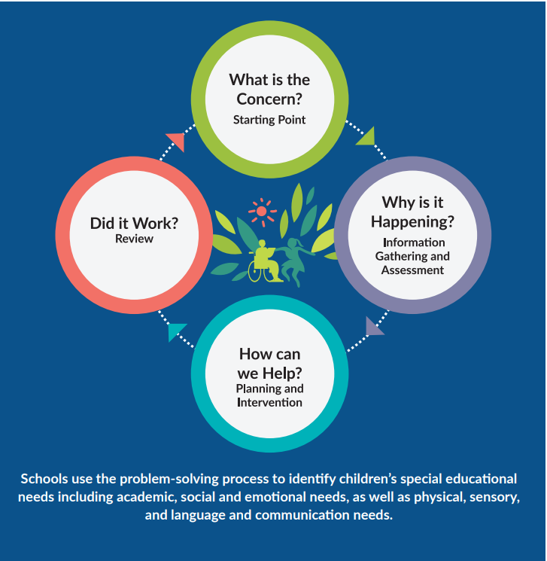

8. Support Teaching

Support teaching will be implemented in the most appropriate way, considering the needs of the student and/or group. This may include collaborative teaching and/or support required in quitter learning environments. This decision will be made by the classroom teacher, the Support Teacher and the student’s parents/guardians.

(i) School support through co-teaching
Several approaches to co-teaching are employed in order to support students. These include, but are not limited to:
• Team teaching
• Parallel teaching
• Station teaching
• Lead and support teaching
Effective co-teaching requires the classroom teacher and the Support Teacher to co-plan, co-teach and co-assess. Regular professional conversations and reflections should take place between the classroom teacher and the SET to inform planning and teaching.

(ii) School support in alternative settings
Where beneficial, students may receive support in a separate learning space. Support is typically provided in small groups. Where needed, students may receive one-to-one support. Teaching is personalised to meet the students individual learning and targets.

9. Tracking and Recording
DES Guidelines (2017) state that monitoring outcomes is part of a dynamic process of identification, target-setting, intervention and review, which in turn should lead to adjustments in School Support Plans. Each student’s progress is monitored using the Support Review Record (contained in the Student Support File) so that class teaching and support teaching continue to be responsive to the student’s needs at all times.
10. Record Keeping
When planning timetables, the classroom teacher and support teacher will ensure that all students receiving support in alternative settings continue to access all areas of the curriculum wherever possible. Support slots maybe schedules daily or several times per week, with flexible timing to best meet the students’ needs.

11. Continuing/Discontinuing Support Teaching

Where support teaching is to be extended after the agreed period, an updated School Support Plan will be developed. This is done in consultation with the Special Education Co-ordinator, classroom teacher, parents and Support Teacher and will reflect any changes that result from the Support Review Record. Support teaching may be discontinued in the following circumstances:
• The student, on assessment, performs above a percentile of 12 in the support area
• Learning targets have been sufficiently met.
• It is considered to be in the student’s best interests. Support will only be withdrawn after consultation with the parents, classroom teacher, Support teacher, principal and student, where appropriate.

12. Parental /Guardian Engagement

We recognise the vital role of parents/Guardians as primary educators in supporting their child and appreciate that parental/guardian engagement is a critical factor in enhancing outcomes for students with special educational and additional needs. Parents/Guardians are consulted in relation to their children’s needs and the strategies being implemented to support them. They are also involved in reviewing their child’s progress. We recognise and respect the parent/guardian’s right to choose not to avail of the recommended support for their child. In such circumstances, parents/guardians will be requested to inform the principal in writing confirming their position.

13. Timetabling

When devising timetables, the classroom teacher and Support Teacher will ensure that all students who are withdrawn for support sufficiently experience all areas of the curriculum, in so far as is practicable. Timetabled support slots may be allocated on a daily basis or several times a week. The support slots vary in lengths of time in order to best meet the needs of the pupils.

14. Continuous Professional Development (CPD) /Teacher Professional Learning (TPL)

As all staff members have responsibility for supporting students with special educational and additional needs, it is important that all staff engage in appropriate CPD to develop the capacity of our school to meet the needs of all students. The principal and BOM facilitate the attendance of the SETs at CPD courses and events, including the annual ILSA and IATSE conferences, in addition to cluster meetings arranged by the NEPS psychologist assigned to the school. SETs will provide a summary of the course content at whole staff level.

15. Supporting Transitions

Transitions have been identified as a significant risk factor to the wellbeing of children with Special Education Needs. Children with SEN should ideally be identified two years prior to the date on which the child is due to transfer from the school. These transitions should be supported by the principal, deputy principal, SET and class teachers.

16. Reviewing this Policy

A comprehensive review and revision of the elements of this Supporting Pupils with Additional Educational Needs policy, will take place in the event of new guidelines or circulars. It can also be reviewed at the request of the BOM, Parents/Guardians or the Staff of METNS.
Implementation Date: 7/11/2025
Formal Review Date: November 2028
Ratification and Communication: This review was ratified by staff and BOM on 06/11/2025
Chairperson: Niall Hare Principal: Lorraine Murray
Appendices

Appendix 1 Student Support File



STUDENT SUPPORT FILE

Name of Student

Date of Birth

School | Maynooth ETNS
Date File Opened

Date File Closed

A Continuum of Support

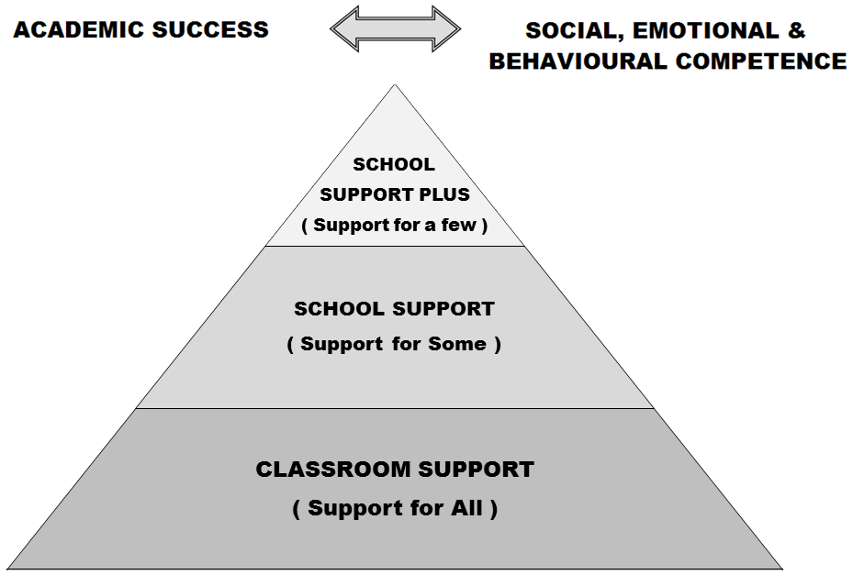

Developing a student support plan is the outcome of a problem-solving process, involving school staff, parent(s)/ guardian(s) and the student. We start by identifying concerns, we gather information, we put together a plan and we review it.
Student Support File, Log of Actions

Date Actions

Support Checklist
Name: | Age: | Class:
General Information | Date Checked | Comments
- Parents/ Guardians Consulted | Yes
- Information from previous school/preschool gathered
- Hearing
- Vision
- Medical Needs | No
- Basic Needs Checklist completed
- Assessment of learning- screening

- Observation of learning style/approach to learning
- Observation of behaviour
- Interview with pupil
- Classroom work differentiated?
- Learning environment adapted?
- Yard/school environments adapted?
- Informal or formal consultation/advice with outside professionals?
- Advice given by learning support/resource teacher or other school staff?
- Other interventions put in place in school?
Action needed
Helpful references: SEN: A Continuum of Support: Resource Pack for Teachers, pp. 13-16, 18 to 20; BESD: A Continuum of Support, p 7; A Continuum of Support for Post-Primary Schools, Resource Pack for Teachers, pp32-36; Student Support Teams in Post-Primary Schools, pp20

SUPPORT PLAN* Classroom Support
School Support (Support for Some)
School Support Plus (Support for A Few)

To be completed by the teacher(s).
For help, see SEN: A Continuum of Support - Guidelines for Teachers: BESD: A Continuum of Support – Guidelines for Teachers pp.71-74; A Continuum of Support for Post-Primary Schools, Resource Pack for Teachers, pp. 51, 53, 54, 57.
Student’s name |  |  | Age
Lead teacher |  |  | Class/year
Start date of plan
Review date of plan
Student’s strengths and interests

Priority concerns

Possible reasons for concerns

Targets for the student

Strategies to help the student achieve the targets
Classroom

Home

Staff involved and resources needed

Signature of parent(s)/ guardian(s)
Signature of teacher
*A consultation with a NEPS psychologist/ other professionals may contribute to this plan.
SUPPORT REVIEW RECORD* Classroom Support
School Support (Support for Some)
School Support Plus (Support for A FEW)
To be completed by the teacher(s) as a review of the plan and as a guide for future actions.
For help, see SEN: A Continuum of Support - Guidelines for Teachers; BESD: A Continuum of Support – Guidelines for Teachers; A Continuum of Support for Post-Primary Schools, Resource pack for Teachers; Student Support Teams in Post-Primary Schools.
Student’s name |  | Class/ Year
Names of those present at review |  | Date of Review
What areas of the plan have been most successful and why?

Since the start of the plan, has anything changed in relation to the original concerns? If so, what are these changes, and what have we learned from them?

Have the student’s needs changed since the start of the plan, and if so how?

Recommended future actions – what, how, who, when?

Any comments from the student?
Any comments from the parent(s)/guardian(s) comment?
Signature of parent(s)/ guardian(s)
Signature of teacher(s)
A consultation with a NEPS psychologist/ other professionals may contribute to this review.
Outcome of review (tick as appropriate)
 | Revert to previous level of support- Support for All/ Classroom Support OR Support for Some/ School Support |  | Progress to next level of support- Support for Some/ School Support OR Support for a Few/ School Support Plus
 | Continue at Current Level of Support |  | Request consultation with other professionals
Appendix 2 Pupil Care Plan
SUPPORT PLAN CONTINUED: ADDITIONAL CARE SUPPORT TARGETS (where additional
care needs are identified)*
To be completed by the teacher(s) in consultation with parents/guardians and staff supporting the additional care needs of the student. The voice of the student should also be captured as part of this process, as appropriate.
Long-Term Care Goals
Care Targets (incorporating the voice of the student)
Strategies to help the student achieve the care targets
Staff, including support staff, involved:
Parent/Guardian input
Frequency of support
Timeline for achievement of targets:
Signature of parent(s)/guardian(s)

Review Date:

Appendix 3 SEN School Provision Plan

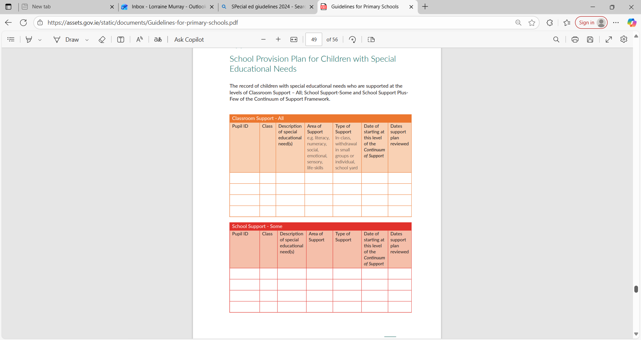
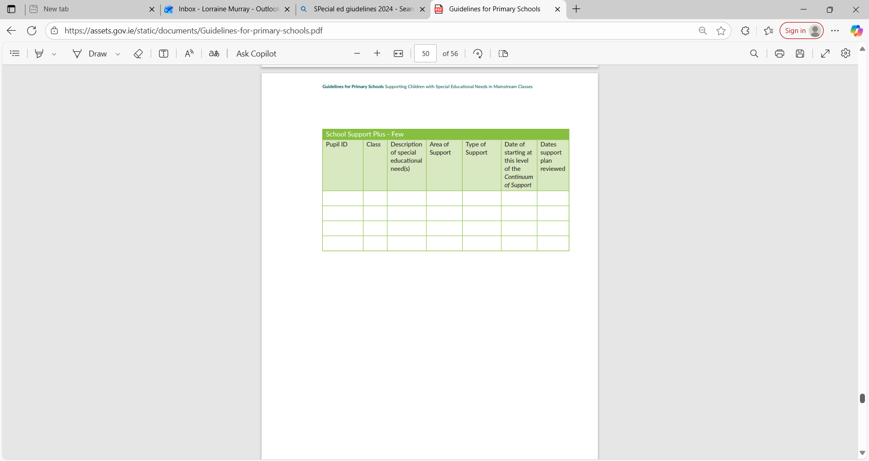
Appendix 4: Target setting as part of the problem-solving framework. From pg. 28 2017 Guidelines
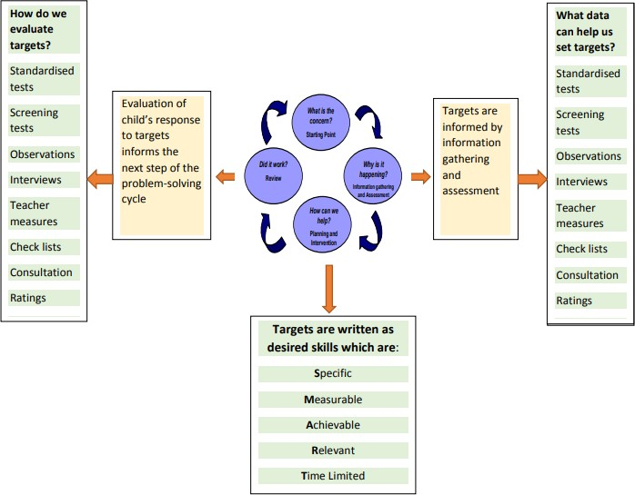

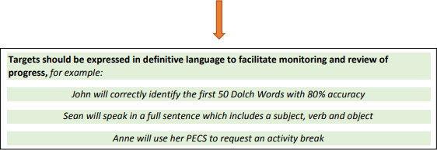

Appendix 5 Solution Focused Behaviour Plan

Solution Focused Behaviour Plan

Child: | Date: | Developed By:

Strengths

Behaviour of Concern

Behaviours we would like to see

Strategies and supports available

Consequences for negative behaviour

Appendix 6 Steps to Follow COS

Outline of continuum of support (Steps to follow when concerns arise over a child)

Stage 1- Classroom support plan
As detailed in the learning support policy, the first step a class teacher should take when concerned about a child is to set up a classroom plan around the child. *please see Appendix 7 for plan templates. This plan should be drawn up and implemented by the class teacher. The plan may also include home- based actions to be taken by the pupil’s parents to support their child’s development. The Classroom Support Plan should include a review date. This could be at the end of a school term.

Stage 2- School Support plan
- A Support Plan at stage 2 is a plan drawn up by the class teacher and appointed SET teacher. Standardised testing and NNRIT results should be consulted. The SET teacher and class teacher should select further diagnostic testing at this stage from the list in Appendix 11.
- If confusion arises over which assessments to use, the SET co-ordinator may be consulted for advice.
- Assessments should be carried out and interpreted by the SET and/or class teacher.
- If advice is needed regarding interpretation of results, the SENCO will be consulted.
- If a specific SEN programme of work is recommended based on testing, SENCO may be consulted. (Please see Appendix 8 for list of SEN programmes available in school.)
- Following diagnostic assessments, a plan should be drawn up for the pupil by the SET and class teacher. It will set out the nature of the pupil’s learning difficulties, define specific teaching, learning and behavioural targets and set a timescale for review. The plan should, for the most part, be implemented within the normal classroom setting and complimented by focused school-based intervention programmes (See point 5 above regarding programmes available).
- Depending on the nature of the needs and on the school context, additional teaching might be within a small group or individual or a combination of both either in class or on a withdrawal basis.
- Home-based actions may also be included. After the plan has been drawn up, it should become a working document through the careful monitoring of the pupil’s response to the actions taken.

Stage 3- School Support Plus
A Support Plan at stage 3 is a support plan or IEP drawn up by the class teacher and appointed Special Education Teacher/s, in consultation with the child’s parents/guardians, the principal, professionals external to the school and (if appropriate) the child based on the information gathered. It will set out;

- The nature and degree of the pupil’s abilities, skills and talents
- The nature and degree of the pupil’s special educational needs and how those needs affect his/her educational development
- The present level of educational performance of the pupil
- The special educational needs of the pupil
- The special education and related support services to be provided to the pupil to enable the pupil to benefit from including:
- Strategies for supporting the pupil’s progress and inclusion in the classroom setting
- Individual and/or small group/special class interventions/programmes
- Specific methodologies/programmes to be implemented
- Specific equipment/materials and/or IT supports, if required to support learning and access to the curriculum
- Support required from a Special Needs Assistant (SNA), if appropriate
- The goals which the pupil is to achieve over a period not exceeding 12 months
- The pupil’s priority learning needs, long and short-term targets to be achieved, the monitoring and review arrangements to be put in place

These planning meetings should be co-ordinated by the SET. Parents will be kept informed of development
Appendix 7: Annual Confirmation to the Board of deploymenent of SET Reousrces
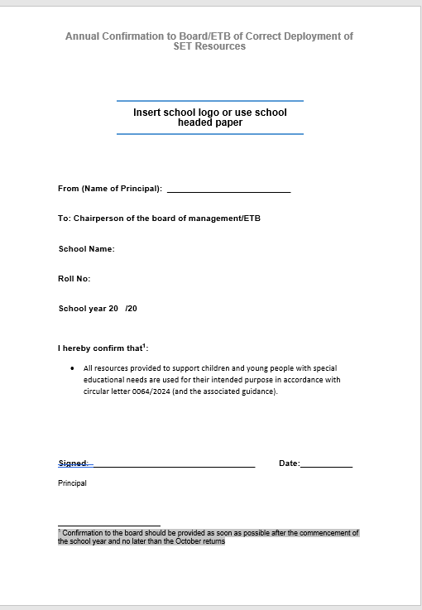

Appendix 8 Basic Needs Checklist

Basic Needs Checklist
This page shows a checklist can be useful in considering a pupil’s basic needs Name:
Headings under which to consider a pupil’s basic needs:
□Physiological needs e.g. does the child have adequate food, warmth, housing etc?
□Safety needs e.g. does the child need physical or psychological protection?
□Belonging needs e.g. does the pupil have close family and friends, feel part of his/her class?

□Esteem needs e.g. does the child receive respect, positive feedback from others and respect others and self?

Possible actions suggested to the teacher on the basis of the consideration of the basic needs questions above:

- Talk to home-school care team re lunch / hygiene
- Offer some healthy foods in school.
- Provide clean jumper / sweatshirt.
- Concentrate on healthy eating and importance of hygiene in SPHE.
- Set up buddy system in class, friendship (buddy) bench in yard.
- Always greet pupil positively when he/she arrives in school (even if late) commenting that you are glad to see them.
- Praise and encourage positive behaviour and effort at work.

- Give child’s parents positive feedback on how they are doing whenever possible.


Examples and further advice can be found online in this document from DES.

https://www.education.ie/en/Schools-Colleges/Services/National-Educational-Psychological- Service-NEPS-/neps_special_needs_resource_pack.pdf

Appendix 9 Learning Environment Checklist

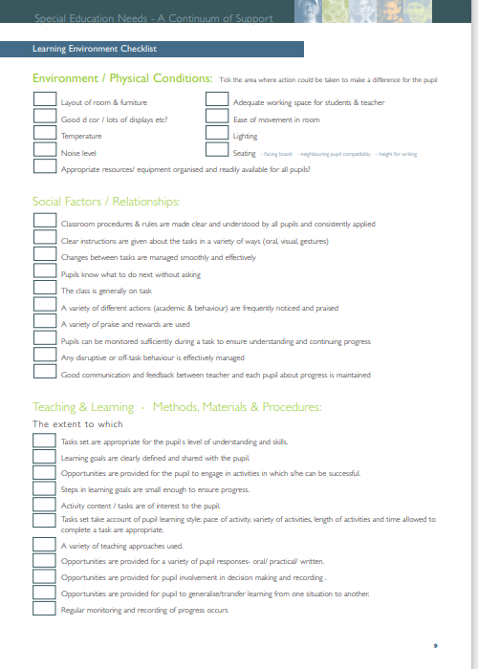

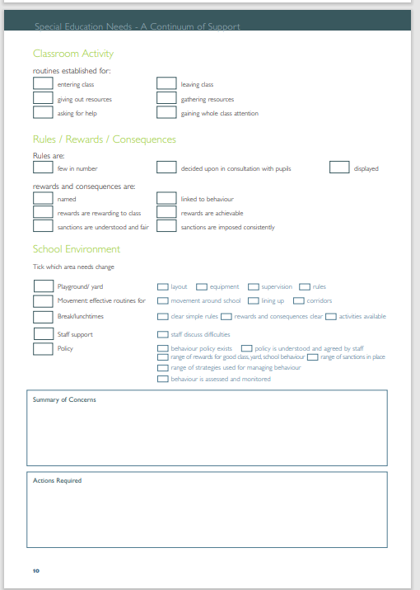

Appendix 10 My Thoughts About School Checklist

My Thoughts About School Checklist...
NAME | CLASS | DATE

The things I like best at school are:
The things I don t like about school are:

The following questions can be asked if children have an emotional and behavioural difficulty in school.

Adults I get on best with in school are:

I get into trouble in school when:

The things I do that make my teacher feel unhappy are:

The things my teacher does that make me feel unhappy are:

I make my teacher happy when:

The things my teacher does that make me feel happy are:
The class rules are:
If someone breaks the rules:
Rewards I like best are:
The things that I need to change are:
Pupil Questionnaire

Description
The questionnaire provides a bank of questions that schools can use to explore the barriers and supports for pupils in school. It uses both open and closed questions using symbolic faces for pupils to rate their experiences as well as more conventional response options. It explores children’s feelings about different times and places within the school, different types of organisation for learning. It asks about children’s experience of difficulties as well as what child find supports them. It also asks them if they have any difficulty, health or medical condition or disability and if it has gone on for a long time. In this respect it asks similar questions to the parent questionnaire.

Presentation the Facilitator
Although this is an activity that pupils can complete on their own it still has to be introduced by explaining why pupils are being asked these questions, who will have access to the information and how the school will use the information to bring about change. It is also important to reinforce the notion that everybody finds some things in life difficult.

The Format
The questionnaire was designed to be used online and this allows the easy use of photographs and colourful symbols that make any questionnaire more attractive. There is some research to suggest that pupils engage more with an online format and it adds to a feeling of anonymity. In contrast a black and white photocopy may be approached as a lesson sheet and completed as compliance but without personal thought or reflection.

The Content
Schools may want to customize the questionnaire. They may wish to simplify the response format for some pupils, possibly giving three options instead of five. They may wish to slightly shorten it. It is useful to remember that easier questions should appear first on the questionnaire and that pupils may write less in the open questions towards the end of the questionnaire.

Anonymity
The advantage of a questionnaire is that the pupils’ responses are not mediated by the presence of an adult. We have made the questionnaire anonymous with the option for pupils to write their name, especially if they wish to have a follow up conversation with an adult. However, if schools wish to use the information to support the learning of individuals in particular need of help, they will want to weigh up whether they want to promise pupils anonymity or confidentiality. The latter has important implications for the way the data is collated and stored and who has access to this.

Collating the Answers
While questionnaires have the advantage of being easy to administer it can be time consuming to collate the answers. There are advantages therefore to making it available online where pupil responses can be collected in a data base. A database can be used to look at differences between groups in terms of what they find difficult and what is supportive. This is important as the aggregated data can inadvertently marginalise the needs of particular groups and make whole school responses inappropriate.

Appendix 11 Assessments Available in the School
List of assessments available in school, this is not an exhaustive list and SET may use other screening assessments that they are familiar with.

Screening Tests
Belfield Infant Assessment Profile (BIAP)
Middle Infant Screening Test (MIST)
Drumcondra Early Numeracy Test
Drumcondra Early Literacy Test
New Non- Reading Intelligence Test (NNRIT)& NVRT
Drumcondra Maths/Literacy Test
Dyslexia Screening Tests including: Bangor Dyslexia test,
Pearson – The Dyslexia Screening Test Junior
ABLLS-R – The Assessment of Basic Language & Language Skills

Diagnostic Tests
YARC -York Assessment of Reading for Comprehension
Malt – Mathematics Assessment for Learning & Teaching
PHAB2 – Phonological Assessment Battery
PSAK – Primary School Assessment Kit (for International students)
VB-MAPP (Verbal Behaviour Milestones Assessment and Placement Program)
Drumcondra Early Literacy Diagnostic Test
Drumcondra Early Numeracy Diagnostic Test
Drumcondra Spelling Test
Other PM Bench Mark 2 – Reading Assessment

Appendix 12 Differentiation
Differentiation
Rationale: Children learn differently. They have different learning rates and styles of learning. Different approaches work with different children. Some children have good visual memories and they will learn best with diagrams, maps, lists, topic webs, flow-charts and may find it easier to show their understanding in this form. Some children remember what they hear (they have a good auditory memory) and they will find it easier to listen, talk about the task and respond verbally. Other children need demonstrations by the teacher, and/ or to watch other students doing the task and to start it themselves before understanding it.

Specifically, differentiation is about: -
Manageable tasks
Ensuring all children are given tasks that match their level of ability and attainment. Achievable tasks
Presenting these tasks so that children can demonstrate what they know, understand and are able to do. Motivating tasks
Allowing children to achieve success and feel the learning experience has been worthwhile.

Types of differentiation:
Differentiation by instructions
Modelling and demonstrating the task while giving instructions and show an example of the finished product
Clarify and shorten instructions- one piece of information at a time.
Use different coloured chalk for each line of text on the board-this helps children who lose their place Underline key words
Use pictures to support understanding
Allow a few seconds thinking time for oral responses
Ensure pupils have a clear understanding of what they have to do and why.
Give summary of lesson — its aims and findings at the end.
Ask pupils who have difficulty following instructions to repeat them back to teacher or a partner.

Differentiation of the task
Varying types of tasks e.g. abstract oral activities vs. experiential, interactive activities. Having different levels of difficulty within a task.
Modifying materials while all children are given a similar task e.g. written tasks, picture tasks, concrete, practical materials.
Children can work on different parts of a task e.g. research different things of interest about Ireland. Use the different interests and talents of pupils

Differentiation by groupings
This will depend on the topic being taught and the size and composition of the class. Use a variety of groups e.g.
Whole class teaching
Mixed ability group - (good for open ended or creative tasks)
Ability grouping - (too much of this type of grouping can lower self-esteem but it is good for certain academic tasks.)
Peer tutoring/ buddy system
Planning and preparation are needed and children may need to be taught to work in groups successfully. Expect higher noise levels. Seat pupils with difficulties where they can see and hear the teacher clearly

Advantages of group work
Prevents teacher dependence - (children can problem solve with friends)
Promotes collaborative and co-operative learning
Enjoyable
Encourages involvement in learning

Differentiation by Output: quality, quantity and how pupils will respond
Using open ended tasks can result in a variety of ways of doing the same activity some of which will be more developed than others. Giving children opportunities to record work in different ways.
In the short-term plan, the differentiation strategies will be developed in greater detail and should be informed by reflection on actual learning outcomes

Appendix 13 SEN Yearly Schedule
 | Overview of the Year (SAMPLE)
September | - SET updating SEN Register and devising timetables  - SET meeting with relevant class teachers/SNA’s  - SENCO and Principal meet with NEPS psychologist  - Autism Class Teachers liaising with class teachers re inclusion plan  - Diagnostic testing
Sept - Oct | - School Support Plans devised (Staff, Parents/Guardians) liaison with outside agencies if relevant.
November | - Parent Teacher Meetings with Class Teachers, relevant SET may join some of these meetings where relevant.  - School Support Plans/Pupil Care Plans Signed off by Teachers/Parents/Guardians
January | - New Targets Set if necessary on Student Support Plan
February/March | - School Support Plan Reviews  - MIST (Middle Infant Screening Test) assessment Senior Infants  - NRIT (Non-Reading Intelligence Test) 2nd and 5th classes
May | - Standardised Testing (1st to 6th classes inclusive)  - School Support Plan Reviews Completed and signed
May/June | - SEN Team and Class Teachers liaising to look at test results, review school support plans, communicate with parents before end of year reports if necessary  - SEN Co Ordinator updating SEN Register  - Transition to secondary passport/communication with secondary school.  - Meeting with pupils/ parents of any incoming JI with additional needs ahead of next academic year.
Monthly | - SEN Team meeting with SENCO & Principal when available

Appendix 14 Schedule of Deployment of Special Education Teachers for Children with Special Educational Needs (Primary)

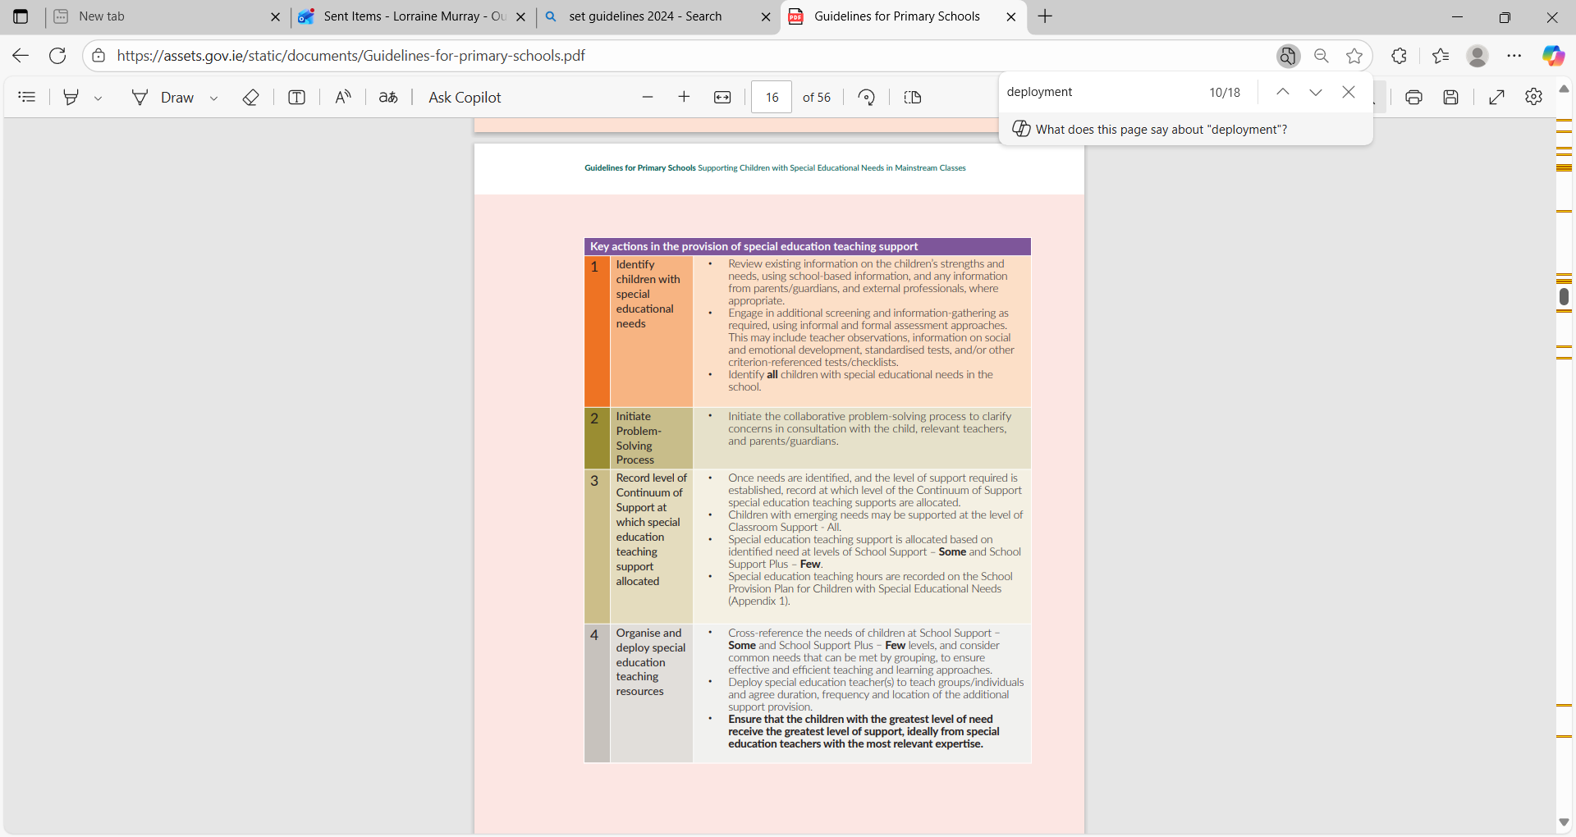
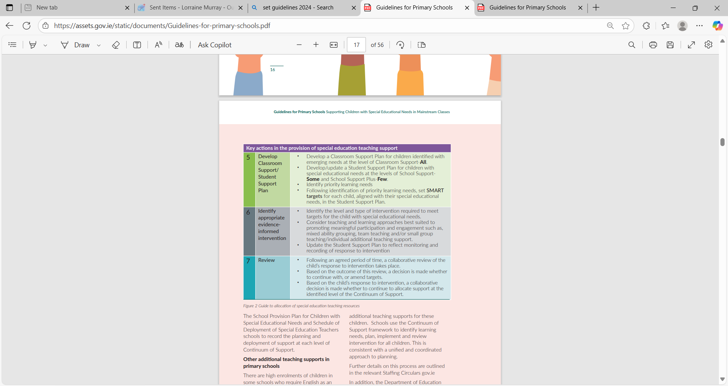

Appendix 15 METNS Policy Glossary of Terms
Acronym | Full Term |  | Meaning / Use
ACN Plan | Additional Care Needs Plan | A care plan developed for students with significant care needs.
BOM | Board of Management | Governing body responsible for school policy and oversight.
CAMHS | Child and Adolescent Mental Health Services | HSE based support service for children's mental health.
COS | Continuum of Support |  | Three-level framework for providing levels of SPECIAL EDUCATIONAL NEED support in schools.
CPD | Continuous Professional Development | Ongoing training and education for school staff.
DEY  DE | Department of Education and Youth  Department of Education |  | Irish government department overseeing education.
EAL | English as an Additional Language | Support for pupils whose first language is not English.
HSE | Health Service Executive | Ireland’s public health service.
IATSE | Irish Association of Teachers in Special Education | Professional network for special education teachers.
IEP | Individualised Education Plan |  | An individual written plan for students with special educational needs.
ILSA | Irish Learning Support Association | Professional body supporting special education staff.
METNS | Maynooth Educate Together National School |  | The name of the school.
NCSE | National Council for Special Education | Agency supporting students with special educational needs in Irish schools.
NEPS | National Educational Psychological Service |  | Government service offering psychological support to schools.
OT | Occupational Therapist / Occupational Therapy | Support related to motor skills, sensory needs, etc.
PSAK | Primary School Assessment Kit | Used to assess students with English as an additional language.
SCPA | Scheme for the Commissioning of Psychological Assessments | Scheme by NEPS that allows schools to access Department-funded psychological assessments by approved private psychologists when a NEPS psychologist is unavailable.
SEN | Special Educational Needs | Additional learning needs requiring extra support.
SENCO | Special Educational Needs Coordinator | Staff member who coordinates special educational needs services in the school.
SENO | Special Educational Needs Organiser | NCSE official assisting schools in accessing resources.
SET | Special Education Teacher |  | Teacher providing support for students with special educational needs.
SLT | Speech and Language Therapist / Therapy | Specialist support for communication and language skills.
SNA | Special Needs Assistant |  | Staff member supporting students with care needs.
SSP Plan | Student Support Plan |  | Support plan designed for pupils who need additional support
TPL | Teacher Professional Learning | Training and professional growth for teachers.

