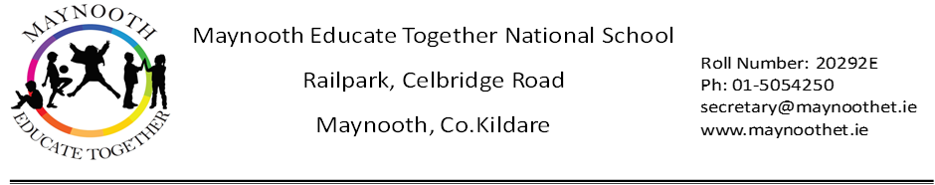

Maynooth Educate Together NS
ANNUAL ADMISSION NOTICE
in respect of admissions for the 2026/2027 school year

Admission Policy and Application Form
A copy of the school’s Admission Policy and the Application Form for Admission for the 2026/2027 school year is available as follows:
To download from our website: www.maynoothet.ie
On request: By emailing secretary@maynoothet.ie or writing to: The Secretary, Maynooth Educate Together NS, Railpark, Celbridge Road, Maynooth, Co. Kildare, W23 P466

PART 1 - Admissions to the 2026/2027 school year

Application and Decision Dates for admission to 2026/2027

The following dates are applicable for admission to Junior Infants

The school will commence accepting applications for admission on | 16th December 2025
The school shall cease accepting applications for admission on | 30th January 2026
The date by which applicants will be notified of the decision on their application is | February 28th 2026
The period within which applicants must confirm acceptance of an offer of admission is | March 12th 2026

Please Note the following conditions will apply when processing applications:
Failure to accept an offer within the prescribed period above may result in the offer being withdrawn. The school will consider and issue decisions on late applications, received after 30th January 2026 in accordance with the school’s Admission Policy.

Autism Classes Application and Decision Dates for admission 2026/2027

The following are dates applicable for admission to the school’s special classes (Caterpillars and Butterflies) which cater for pupils with Autism.

The school will commence accepting applications for admission on | 16th December 2025
The school shall cease accepting applications for admission on | 30th January 2026
The date by which applicants will be notified of the decision on their application is | February 28th 2026
The period within which applicants must confirm acceptance of an offer of admission is | March 12th 2026

Please Note the following conditions will apply when processing applications:
Failure to accept an offer within the prescribed period above may result in the offer being withdrawn. The school will consider and issue decisions on late applications, received after 30th January 2026 in accordance with the school’s Admission Policy. A compulsory letter of eligibility from NCSE must be submitted with your application.

Number of places being made available 2026/2027

Junior Infants: The total number of places being made available in junior infant classes is… | 50
Special Classes (for pupils with a diagnosis of Autism):  The number of places being made available in the special classes catering for children with Autism. | 2
The number of places being made available in other year groups is…  NOTE: Numbers depend on specific circumstances in each class. | Applications Welcome

Part 2-Admissions to the 2025/2026 School Year

Oversubscription Record

Information regarding the admission process for the Intake Group for Our Autism Classes 2025/2026

Breakdown of places allocated in our classes for pupils with Autism for the 2025/2026 school year

Number of places available | 4
Number of applications received | 23
Numbers of offers made and accepted under each criteria | Offers made and accepted under Criterion 1: Pupils already enrolled in Maynooth Educate Together NS  2 places offered: 2 accepted
Numbers of offers made and accepted under each criteria | Offers made and accepted under Criterion 2: All others  2 places offered: 2 accepted
Total number of offers made | 4
Number of names placed on waiting list for the school year concerned | 19

Information regarding the admission process for the Intake Group for Junior Infants 2025/2026

Breakdown of places allocated in Junior Infants for the 2025/2026 school year

Number of places available | 50
Number of applications received | 115
Numbers of offers made and accepted under each criteria | Offers made and accepted under Criterion 1: Siblings of pupils already enrolled in Maynooth ETNS  23 places offered: 23 places accepted
Numbers of offers made and accepted under each criteria | Offers made and accepted under Criterion 2  62 places offered: 27 accepted
Total number of offers made | 112
Number of names placed on waiting list for the school year concerned | 4

