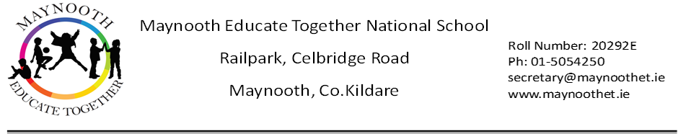

**Maynooth Educate Together NS**

**ANNUAL ADMISSION NOTICE**

**in respect of admissions for the 2025/2026 school year**

**Admission Policy and Application Form**

A copy of the school’s **Admission Policy** and the **Application Form for Admission** for the **2025/2026** school year is available as follows:

To download at: [www.maynoothet.ie](http://www.maynoothet.ie)

On request: By emailing secretary@maynoothet.ie or writing to: The Secretary, Maynooth Educate Together NS, Railpark, Celbridge Road, Maynooth, Co. Kildare, W23 P466

**PART 1 - Admissions to the 2025/2026 school year**

**Application and Decision Dates for admission to 2025/2026**

The following dates are applicable for admission to **Junior Infants**

|  |  |
| --- | --- |
| The school will **commence** accepting applications for admission on | **16th December 2024** |
| The school shall **cease** accepting applications for admission on | **30th January 2025** |
| The date by which applicants will be **notified** of the decision on their application is | **February 28th 2025** |
| The period within which applicants must **confirm** acceptance of an offer of admission is | **March 12th 2025** |

**Please Note the following conditions will apply when processing applications:**

Failure to accept an offer within the prescribed period above may result in the offer being withdrawn. The school will consider and issue decisions on late applications, received after 30th January 2025 in accordance with the school’s Admission Policy.

**Special Class Application and Decision Dates for admission 2025/2026**

The following are dates applicable for admission to the **school’s special classes** which cater for pupils with **Autism**.

|  |  |
| --- | --- |
| The school will **commence** accepting applications for admission on | **16th December 2024** |
| The school shall **cease** accepting applications for admission on | **30th January 2025** |
| The date by which applicants will be **notified** of the decision on their application is | **February 28th 2025** |
| The period within which applicants must **confirm** acceptance of an offer of admission is | **March 12th 2025** |

**Please Note the following conditions will apply when processing applications:**

Failure to accept an offer within the prescribed period above may result in the offer being withdrawn. The school will consider and issue decisions on late applications, received after 30th January 2025 in accordance with the school’s Admission Policy.

**Number of places being made available 2025/2026**

|  |  |
| --- | --- |
| **Junior Infants:** The total number of places being made available in junior infant classes is… | **50** |
| **Special Classes (for pupils with a diagnosis of Autism):**  The number of places being made available in the special classes catering for children with Autism. | **Junior Autism Class: 4**  **Senior Autism Class: 0** |
| The number of places being made available in other year groups is…  **NOTE:** Numbers depend on specific circumstances in each class. | **Applications Welcome** |

**Part 2-Admissions to the 2024/2025 School Year**

**Oversubscription Record**

**Information regarding the admission process for the Intake Group for Our Autism Classes 2024/2025**

|  |  |
| --- | --- |
| **Breakdown of places allocated in our classes for pupils with Autism for the 2024/2025 school year** | |
| **Number of places available** | **2** |
| **Number of applications received** | **13** |
| **Numbers of offers made and accepted under each criteria** | **2 offers made under Criterion 1**  **-**pupils already enrolled in Maynooth Educate Together NS  2 places offered: 2 accepted |
| **Total number of offers made** | **2** |
| **Number of names placed on waiting list for the school year concerned** | **11** |