**April Newsletter**

***School News***

**Hot meals** launched yesterday @ Maynooth ETNS. There was great excitement, delicious smells and lots of empty platters. Our fabulous kitchen is state of the art and HSE standard. A very warm welcome to our lovely lunch ladies Anna, Kathryn and Leanie who are doing a super job.

Please continue to send in some spare food with your children (especially if they are less adventurous with tasting new foods), to ensure that they will not remain hungry and to check in with your children to see what foods they are enjoying/not enjoying. This will help with future ordering.

**An important reminder to continue to send in the morning snack and a drink every day as these are not provided by the school/school food company**. To save on waste, please cancel your child’s order before 10pm the night before (if possible) if you know your child will be absent.

**Some comments from the children:**

*‘I absolutely love these hot meals’*

*‘The curry was very spicy’*

*‘The beef stew was so delicious; OMG I ate it all’*

*The soup- ‘It resembles what it says on the menu’*

*‘Exquisite!!!!’*

*‘it’s bangin’ 😊*

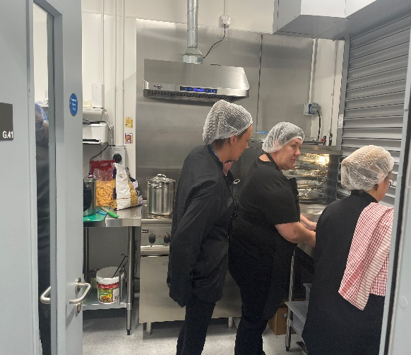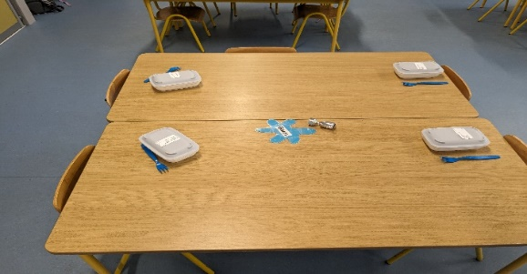

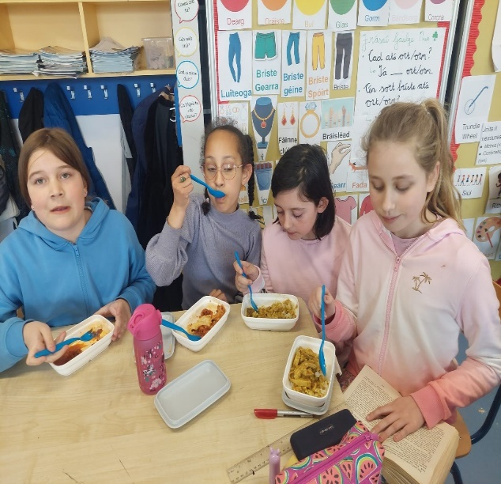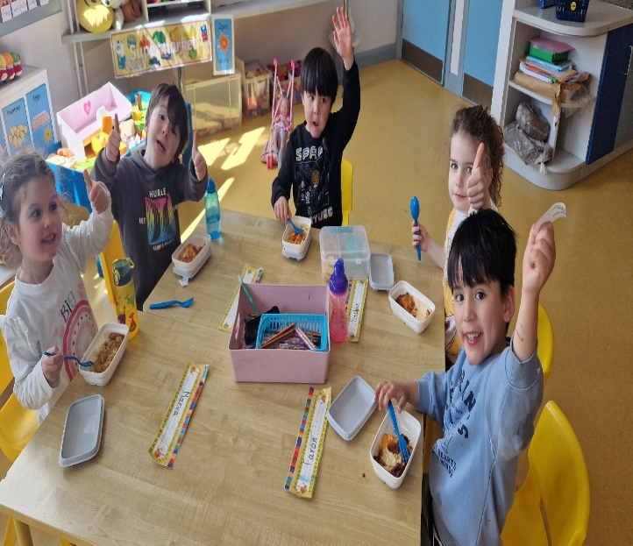

**Delicious!!!!**

**Standardised testing** will take place in late May. It is very important that pupils are in attendance for these tests so please be mindful of unnecessary absenteeism.

**Incoming Junior infant Parent/Guardian Night** (2024/2025) takes place in the school hall on 16th May @ 7:30pm. This meeting is for parents/guardians only and children should not be in attendance. The pupils will meet their class teacher at a later point (May 30th).

**Inclusion and Diversity Week**

We had a fantastic educational and inclusive week from 15th-19th April, whereby we celebrated our differences and similarities. We focused on dyslexia, dyspraxia, ADHD, Autism, medical conditions, Traveller and Roma communities, Down Syndrome, LGBTQ+ etc. We had some past pupils visit the school on Autism awareness day too. It was fantastic to see how well they are doing in their post primary setting. Check out the beautiful sock puppets made by some of our pupils below (Laoise’s 6th Class) to help raise awareness around Down Syndrome. Staff and pupils wore odd socks and colourful clothes last Friday to raise awareness also and sported our new Inclusion and Diversity t-shirts for the week. A sincere thanks to our wonderful team of SNAs (Joan, Cristina, Amanda, Pam, Eileen, Alison, Anne, Lorraine and Sarah who co-ordinated the whole week). They did a fantastic job.

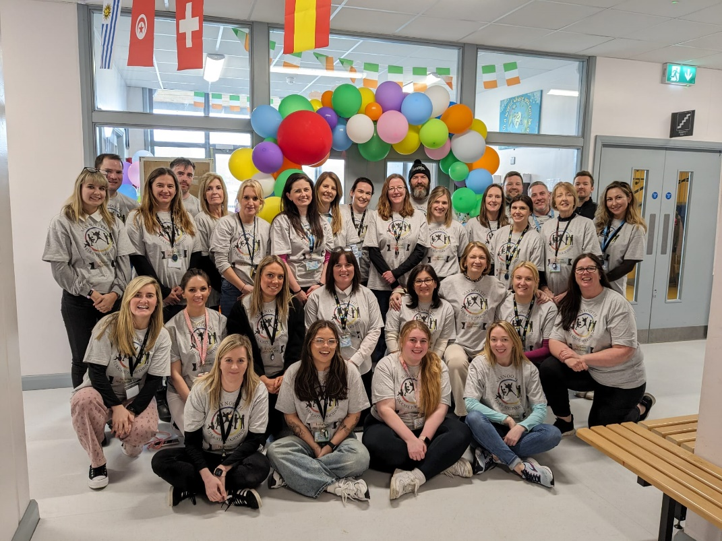

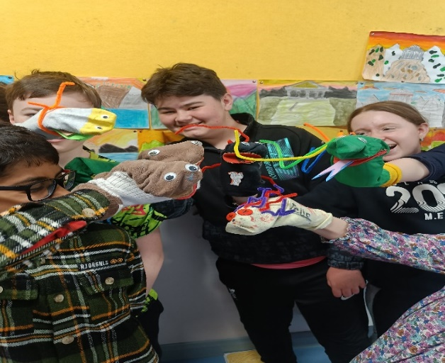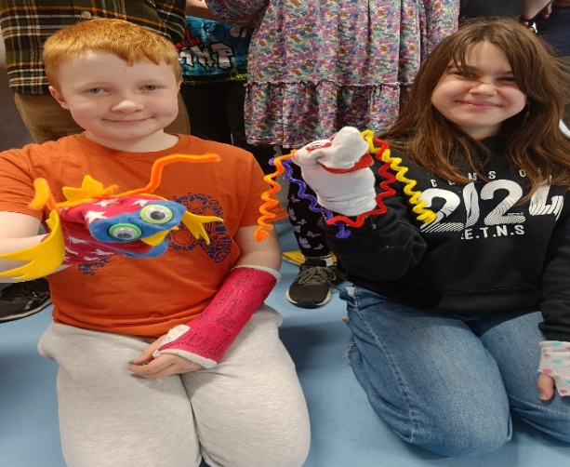

**6th class** were busy making sock puppets last Friday to conclude Diversity and Inclusion Week. Thank you to Joan for supplying materials and well done to all in 6th class on their creative designs!

**School Tours**- are now all booked and payments can be made via Aladdin. The majority of tours are in the month of June. We may require some support from parents/guardians to attend with us and class teachers will be in contact at a later point.

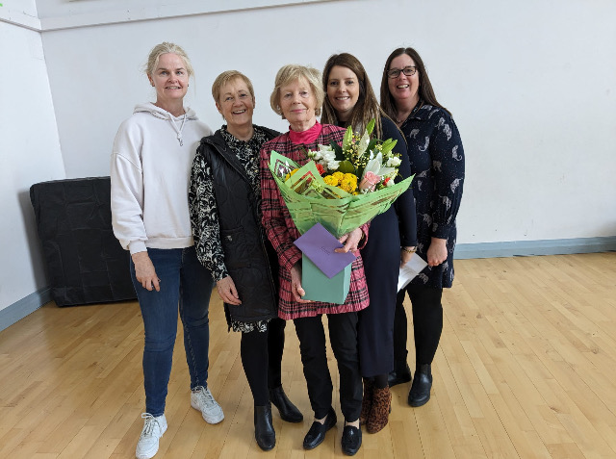

**Farewell to Carmel (pictured above)**. Longstanding after school sacramental preparation teacher Carmel has bid us farewell and has retired. We wish to thank Carmel for all her many years of dedication and service to the pupils, parents/guardians of Maynooth ETNS and we wish her a long and happy retirement. Carmel received a lovely send off last Thursday from pupils and staff. Past principal Marie Hand and parent (Bernie Canning) were also in attendance. Bernie and a group of parents recruited Carmel way back in 2011.

**March Student Awards**

|  |  |  |  |
| --- | --- | --- | --- |
| Class | Student Award | Gaeilgeoir na Míosa | Friendliness Award |
| Junior Infants  Noreen and Sinead G. | Targunn | Conor | Faron |
| Junior Infants Elaine | Paola | Nico | Katryn |
| Junior Infants Sinead S. | Aatral | Hayden | Charley |
| Senior Infants Carolina | Vihaa | Alicja | Lorenzo |
| Senior Infants Aoibhín | Lucy | David | Amaan |
| 1st Class Rob P. | Olivia | Oskar | Ruben |
| 1st Class Catherine | Kacper | Aral | Cadhla |
| 2nd Class Olivia | Noah | Danny A. | Deniz |
| 2nd Class Jennifer | Brody | Tytus | Clia |
| 3rd Class Rob L. | Beatrice | Alden | Atyaf |
| 3rd Class Jacinta | Milosz | Alexander | Noor |
| 4th Class Aimee | Elana | Talha | Maria |
| 4th Class Dave | Maya | Tilda | Mikael |
| 5th Class Tom | Dastin | Alex | Lavinia |
| 5thClass Sue | Neriah | Tate | Oisín |
| 6th Class Laoise | Caoimhe | Maddie | Fionn |
| Caterpillars and Butterflies | Melissa |  | Charlie |

**Upcoming Events/Closures This Term**:

***May****- Standardised Testing*

***May 19th****- Summer Fair (PTA)*

***School closure*** *-May Week- 6th-10th*

***June 3rd*** *(Bank Holiday)*

***June 17th-21st*** *Active School Week*

***June 26th*** *– 6th Class Graduation @ 7:30 pm*

*School Closes for* ***Summer Break*** *on 28th June (Half Day)*

**CLASS NEWS**

The children in **Elaine's Junior Infants** have been learning all about Spring, signs of Spring and the animals born in Spring. In Aistear we have been learning all about the pizza restaurant. Some impressive pizzas have been made and ice cream is a popular choice for dessert.

In Learn Together we have been discussing the value of positivity, we learned all about **Ramadan and Edi.** We also learned a little about how different people are unique during **Equality & Diversity week**. In maths we have been sequencing and ordering numbers and have been playing dice and card games to help with addition.

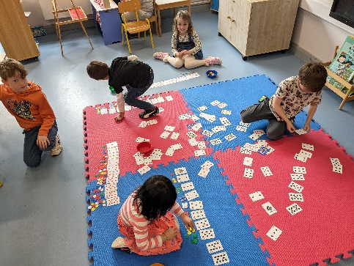

We were learning about healthy foods and the food pyramids in **senior infants (Aoibhín’s class)**. The children made some delicious fruit smoothies. We also had such a special week celebrating Inclusion and diversity week.

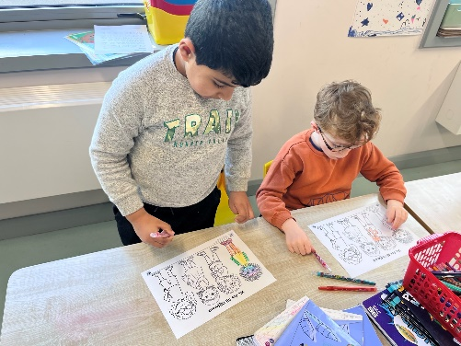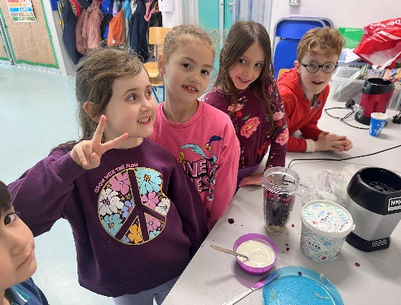

**4th Class Elm** **(Aimee’s class)** were busy learning all about **Japan** with Brenda their student teacher over the last few weeks. They compared new and old Japanese artefacts and looked at similarities and differences between Japanese writing and phonics in English. In addition, they painted a stunning class cherry blossom tree and are now working on making Japanese lanterns.

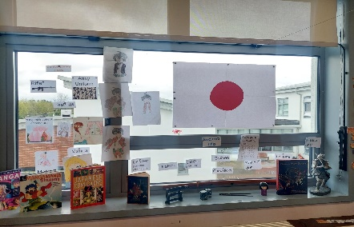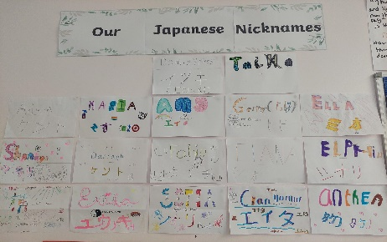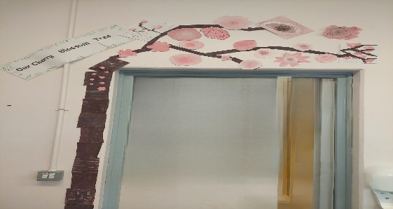

**Junior Infants (Sinéad’s class)** really enjoyed celebrating Inclusion and Diversity week. We watched some lovely videos that showed us the beautiful and diverse population of our school and did some fun colouring activities. We also designed odd socks for Down Syndrome day!

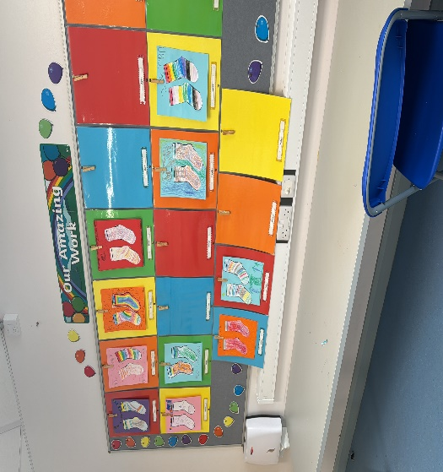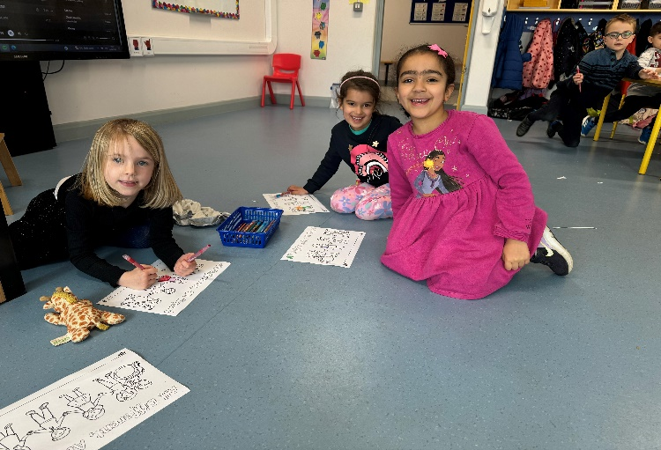

It has been a busy few weeks for **Eoin’s** **Butterflies Class**. We have been celebrating spring and created some wonderful flower art through the medium of print and also using cardboard to construct flowers. We have also been celebrating new life and made some cool lamb art and hatching eggs. Over the last two weeks, we have been making pizzas with a puff pastry base and used our new air fryer to make sweet potatoes cubes and cauliflower “wings”. We have restarted swimming and the children loved being back in the pool. We all had the pleasure of meeting our former classmate Conor in the swimming pool!! A special thanks to the Glenroyal Hotel for providing us with this valuable swimming slot.

**Noreen and Sinéad’s Junior infant class** are making great use of their new maths equipment and are engaging with the new primary maths curriculum. Our resources were kindly funded by our PTA. In addition to exercising their minds they are exercising their bodies learning new basketball skills.

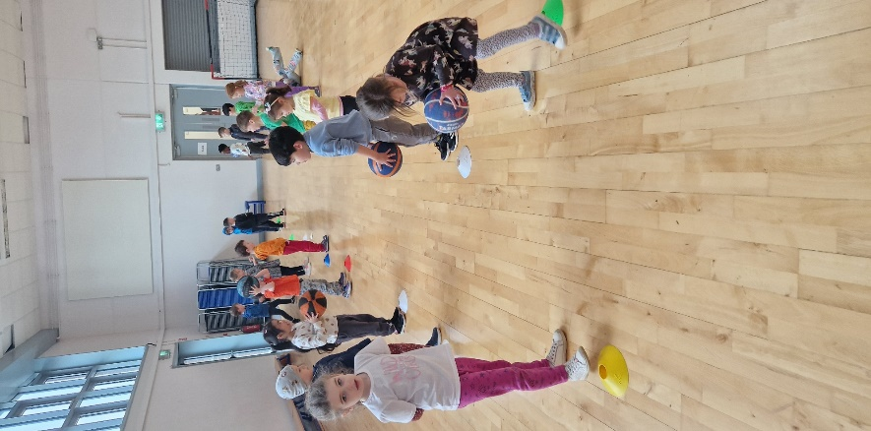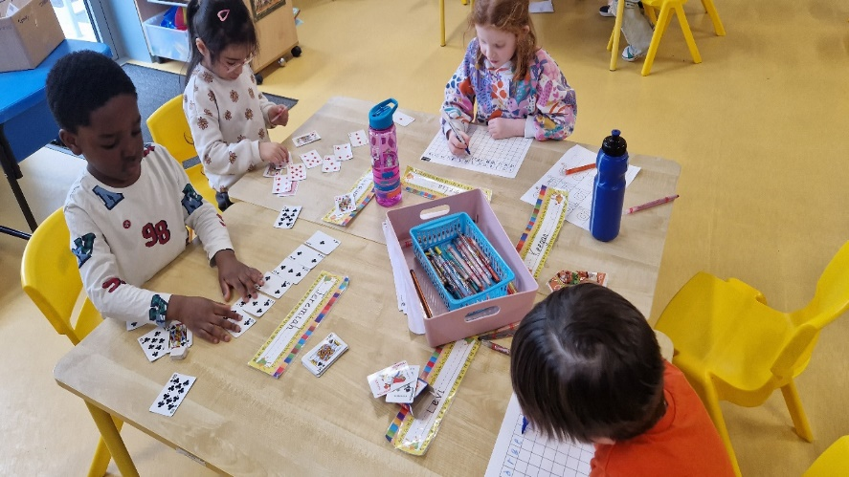

**Both 1st classes** **(Robert and Catherine’s classes)** have been very busy in recent weeks. We have been learning all about magnets and created some brilliant magnet obstacle courses using Lego. In maths we have been learning about weight and having fun using scales to compare how heavy and light some objects are. In English we have been learning how to write cinquain poems.

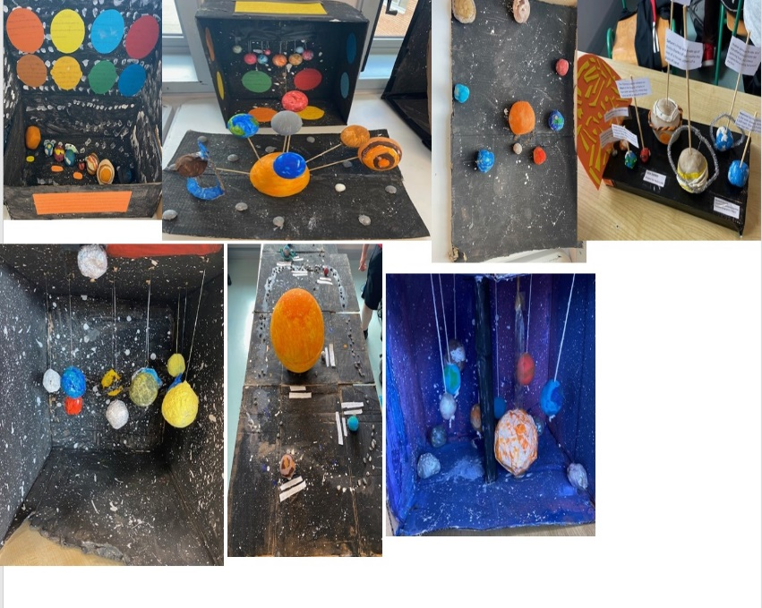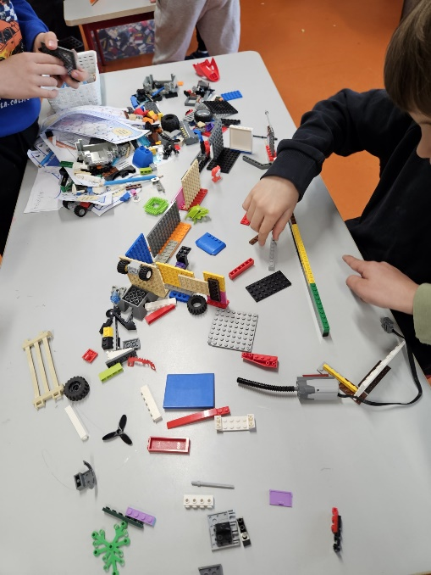

**5th classes (Sue and Tom’s classes)** have worked extremely hard on their solar system projects. All groups showed superb teamwork and great creativity. If anyone is looking for any interesting facts about the solar system, be sure to ask any of the 5th class pupils.

In **3rd Class (Rob. L and Jacinta’s classes)** this month, we learned about Pablo Picasso and some of his creative works of art. We focused on the Picasso Faces and took inspiration from his idea to create our own portraits. 3rd Class have also started back a final block of GAA which is very popular with everyone.

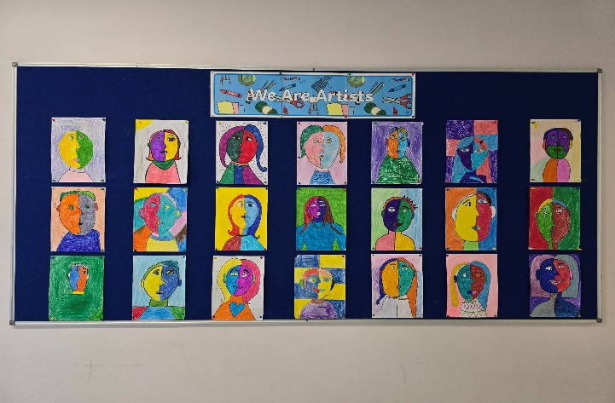

**School Self Evaluation/Spring Clean**: Following parental/guardian, staff and pupil feedback, we have been working extremely hard this year on wellbeing and dignity and respect in the workplace. We strive to improve our physical surroundings, the level of happiness and feeling of safety for the whole school community. Now that the weather is improving, our next focus is our **school garden and outdoor classroom**. If you are available for our clean up this **Friday @ 1:15pm**, we would be most grateful. Bring along your gardening tools.

**PTA**- have their next meeting virtually tonight @ 8pm. Please send link sent out to parents/guardians earlier in the week.

**PTA Summer Fair** (see email for more details)

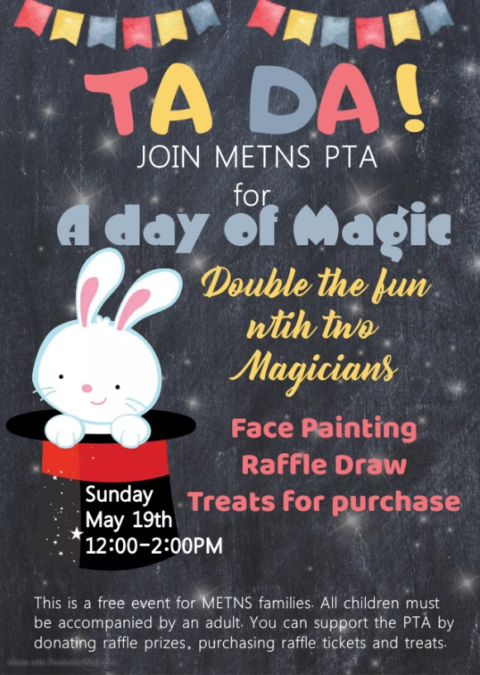

Kind regards,

Lorraine Murray

Principal