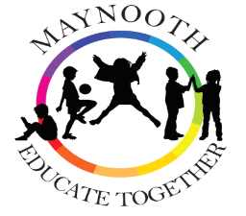

Maynooth Educate Together Newsletter
June/July 2023

Dates to Remember
School reopens: Thursday August 31st at 8.30am.

Teacher Recruitment: There have been a number of staff changes in recent weeks. We wish both Laura and Rachael well as they move on to new school placements.
Marcella Maher, due to teach 6th class in the next school year, has resigned her position in our school. We thank Marcella for her great work in our school and wish her well in her future teaching placement. Marcella has been replaced by Laoise Flanagan. Laoise will teach 6th class next year. Laoise has taught 6th class in the last school year, so she has experience in this class level.

Senior Infants class Hawthorn, which had been allocated to Stephanie, will be taught by Aoibhin Hutchnson, for the entire

school year. When Stephanie returns from her maternity leave, she will join the Special Education Team. Aoibhin has previous teaching experience.

Finally, Second Class Hazel, previously allocated to Grainne, will now be taught by Jennifer Gormley. Jennifer also has previous teaching experience

Revised Class – Teacher allocation for the school year 2023-2024:
The following are the class/teacher allocation for the coming school year.

Revised Class Teacher list 23-24.
CLASS | TEACHER | CLASS IN 22-23
Junior Infants | Elaine
Junior Infants | Sinead S
Junior Infants | Noreen/Sinead
Senior Infants | Aoibhin– Hawthorn | Liz’s class
Senior Infants | Carolina – Cherry | Elaine’s Class
1st Class | Clare D – Ivy | Own Class
1st Class | Robert P – Aspen | Stephanie’s Class
2nd Class | Angela – Ash | Rob L’s Class
2nd Class | Jennifer– Hazel | Rob P’s Class
3rd Class | Robert L – Rowan | Classes to be  Re-arranged
3rd Class | Jacinta – Willow
4th Class | Dave – Oak | Classes to be  Re-arranged
4th Class | Aimee – Elm
5th Class | Sue – Alder | Dave’s Class
5th CLASS | Thomas – Birch | Sinead’s Class
6th Class | Laoise– Chestnut | Thomas’s Class
Junior ASD | Ruth – Caterpillars
Senior ASD | Eoin - Butterflies
SEN | Mary
SEN (Cont’d) | Liz
 | Claire Dixon
 | Catherine

School Books: As you are aware, the Department of Education has introduced a grant-assisted free book scheme for all primary school children. In recent weeks, these books have been purchased and they now have been delivered to the school and await the pupils in each classroom. Very sincere thanks to our Special Needs Assistant, Joan, for her great work in this mammoth task. Copies, notebooks and pencils/pens are included.

Student Assembly Awards: Throughout this school year, our pupils have received awards for their efforts and their application to their work, and also for their positive engagements with each other. Many children have won these awards and they are a great opportunity to encourage children to make their best effort and to act responsibly and kindly towards each other.

June 2023 Student Awards
Class | Student Award | Handwriting Award | Gaeilgeoir na Míosa
Junior Infants Liz | Carter | Martyna | Elliot
Junior Infants Elaine | Alicja | Sofia | Dalton
Senior Infants Clare | Logan | Leandra | Maya
Senior Infants Stephanie | Anya | Alfie | Shane
1st Class Rob L. | Zoey and Danny F | Alfie and Sofija | Verner and Uliana
1st Class Rob P | Brody | Billy | Electra
2nd Class Angela | Felix | Fabian | Noor
2nd Class Jacinta | Daniel and Emily | Vishelnoel | Lydia
3rd Class Sue | Grace | Cara | Skye and Zakariya
3rd Class Mary | Talha | Leonardo | Cillian
4th Class Sinead | Charlie and Alberto | James | Dastin
4th Class Dave | Daniel | Emi | Shayan

Summer Education Programme: the pupils in our Caterpillars and Butterflies classes availed of the Department of Education funded In-school Summer Programme, from July 3rd to July 14th inclusive. The children continued with their schooling and also some additional social and fun activities.
The Department of Education funded Home-based summer education programme is a scheme that is available for children with complex special educational needs. The programme is broad-based and should be tailored to the individual needs of the child.
A number of our pupils are availing of this home-based Summer Schooling Programme.

School Picnic Benches: As part of our school yard development, we have purchased some round-table picnic benches. These may be use at play-times or as an outside classroom. Martin is assembling these at present so the children may avail of them on return to school.

School Awards noticeboard: Photos of our monthly assembly reward winners may be seen on this noticeboard outside the school hall.

School Photograph gallery: We have commenced a School photograph gallery, where we have photographs of all of our Sixth class school leavers to date. All future Sixth class leaver classes will be added to this gallery.

Sixth Class News: Graduation: On Wednesday night the 28th of June we had our Graduation ceremony for the 6th class of 2023. This night is always a very special occasion in the school calendar. The class of 2023 had decided on the theme of movies and the quote “You Set the Stage for Success” was the chosen quote. 6th class and a very talented Margo created a beautiful piece of art. This was presented to Marie and will be hung in the reception area as a memory of the class of 2023.The children received their certificates and medals. The graduation ceremony was packed full of singing, music, poems and a trip down memory lane. On the night we said goodbye to 35 amazing students who all move forward to their next adventure in secondary school. We said a special goodbye to 19 families who now have ended their time as part of our school community.
On Thursday morning the 6th class had a very special graduation breakfast before they left the school for the last time as METNS students clapped and cheered on their way by all the students and teachers.
With this class leaving, we said goodbye to 19 families from the school. The families are: Brzostowska, Cody, Dabrowsky Haverty, Doherty, Gilles, Moran, Ratz Garrido, Uhlemann, Walczak-Sztana, Zdyb, Zheng, Brunnock, Connolly, Hamza, Lowings, McMahon, Savkiv, Smith, and Wang. We thank these families for their contribution to the school.
As is our practice, the Parent Teacher Association funded the customised hoodies for our Sixth class pupils. Rather than present them on Graduation night, these hoodies were presented earlier in the last term, and the children enjoyed wearing them to school regularly. They were worn for the class photograph which hangs on the school photo gallery.
The PTA also funded the super Graduation cake.
Very sincere thanks to all who contributed to the Graduation ceremony. We wish our 6th class success in secondary school.

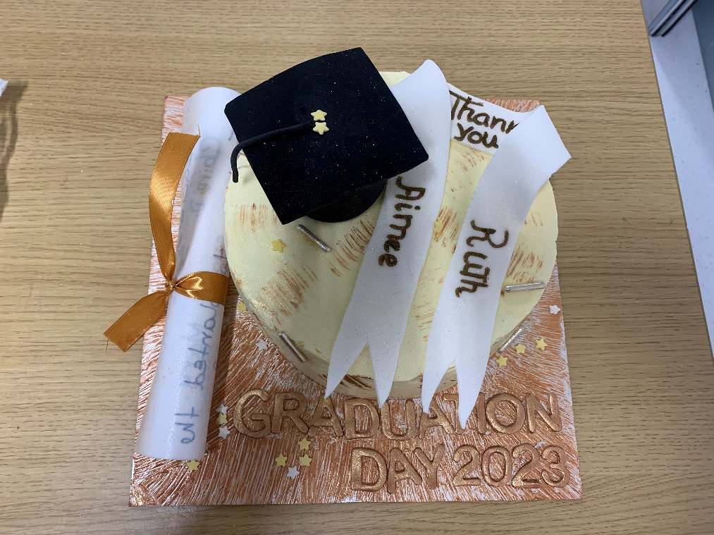

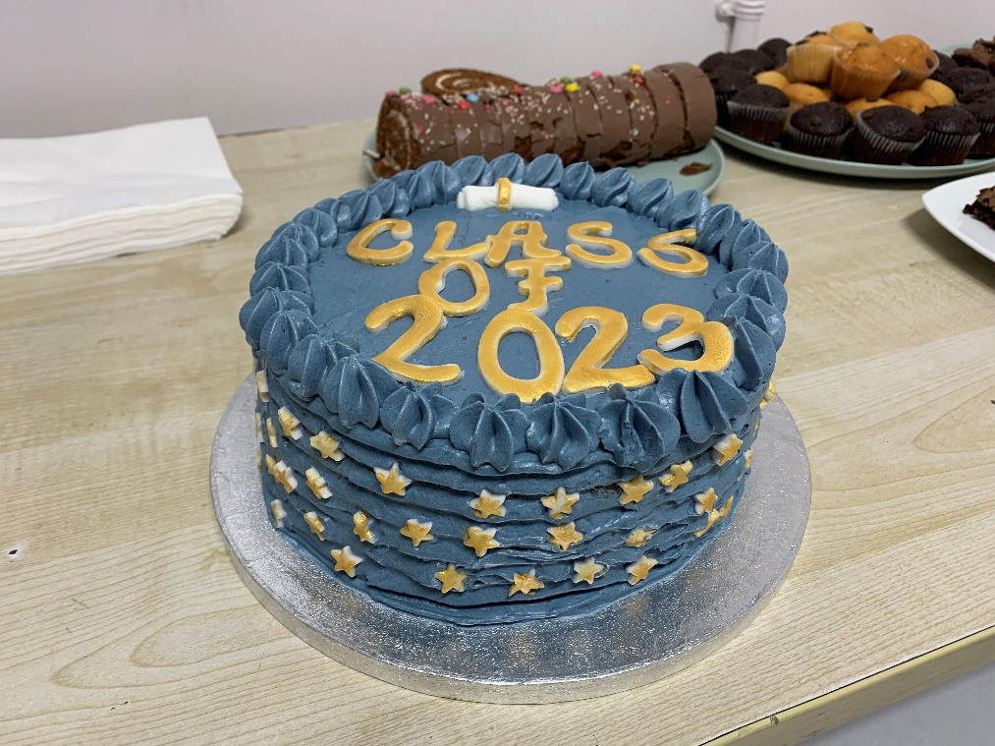

Official School Opening: The official opening of our school building took place on June 22nd. It was a wonderful occasion to showcase the school, and our pupils, who were fully engaged in the ceremony. We started with the Maynooth Band, who entertained the gathering crowd. Elaine, our Deputy Principal, acted as MC for the occasion. Our current Chairperson Niall, and our previous Chairperson, Paul and our Patron representative Emer Nowlan, all spoke and celebrated our school patronage, Educate Together.
Two of our very talented pupils played some music then, Enjuan on the cello and her sister Enxia on the keyboard. This was a wonderful performance. Our Junior choir and our Senior choir both sang, conducted by teacher Ruth. I thanked those who had contributed to the school to date, and the Department for providing us with a state-of-the-art modern building in which to educate our pupils. Pupils Ruben, Abigail, and Patrycja then recited the school poem and chant. These had been composed by the students council, in honour of the occasion. Another students council project produced the School Mascot. This was introduced by Emily, Lavinia and Antoni and by the artists David, India, Margo and Zofia. The School Mascot was named LeCheile: LeCheile will be produced in 3-D shape in the next school year and will accompany our pupils on their school outings and sporting events. A very talented group of musicians from 6th class, (Josie, Adam L, Abigail, James S, Oscar, Gabby, Amira, and James G) then performed on a variety of instruments. This again showcased a hugely talented group of musicians. The cutting of the ribbon and the unveiling of the plaque

was performed by Emer Nowlan, Marie Hand, Niall Hare and Paul Croghan. The event closed with a rousing and colourful rendition of
the Waving Flag Song. The children waved flags representing the many nationalities of children within our school, which number over 35.
In our school hall, all invitees enjoyed refreshment and toured the school. It was a wonderful occasion for Maynooth Educate Together NS.

Very sincere thanks to all staff and pupils whose work, energy and commitment made the occasion so special. Sincere thanks also to the Board of Management who provided the refreshments. Sincere thanks to the entire school community, our Maynooth community partners and to Educate Together, and to all who have journeyed with us to bring our school to where we are today.

Maynooth Educate Together School Chant 2023

We’re all in this together; we’re Educate Together
We don’t need a crest
We strive to be the best
We pave the path to success
We rise above the rest.
We’re Educate Together
We’re all in this together

Maynooth Educate Together School Poem 2023

Maynooth Educate Together is the best,
Our teachers listen to what we suggest.
We respect each other’s views, so we don’t get into fueds.
We always try our best, whether it’s playtime or a test.
We’re diverse, inclusive and kind, and we’re allowed to speak our mind.
We learn and explore and we open up our door.
We strive to do our best, each and every day,
Together we flourish in our own unique way.
From Caterpillars to Sixth, whether you are white, black or mixed,
We accept you as you are, because you will always be a star.
Maynooth Educate Together, a place full of zest,
Teachers and students work together, so our dreams can manifest.

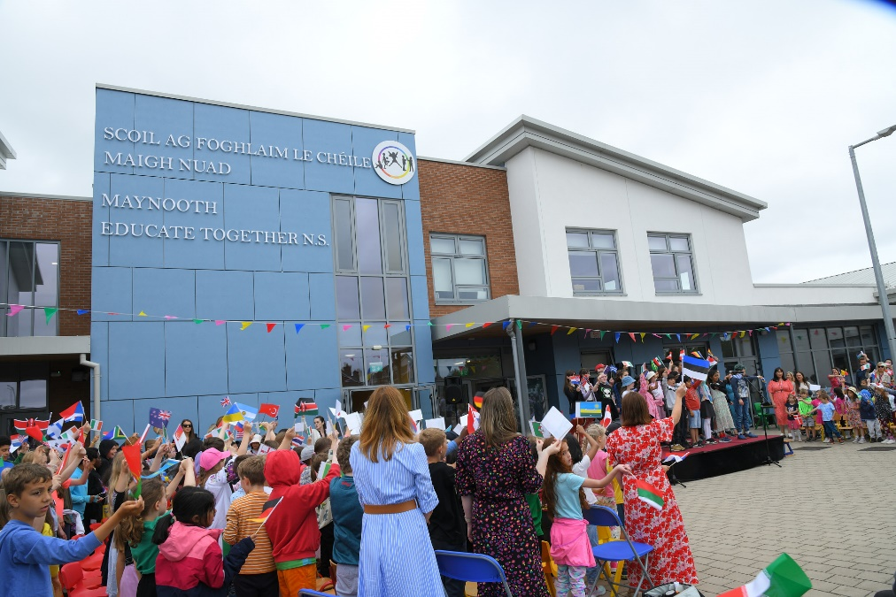

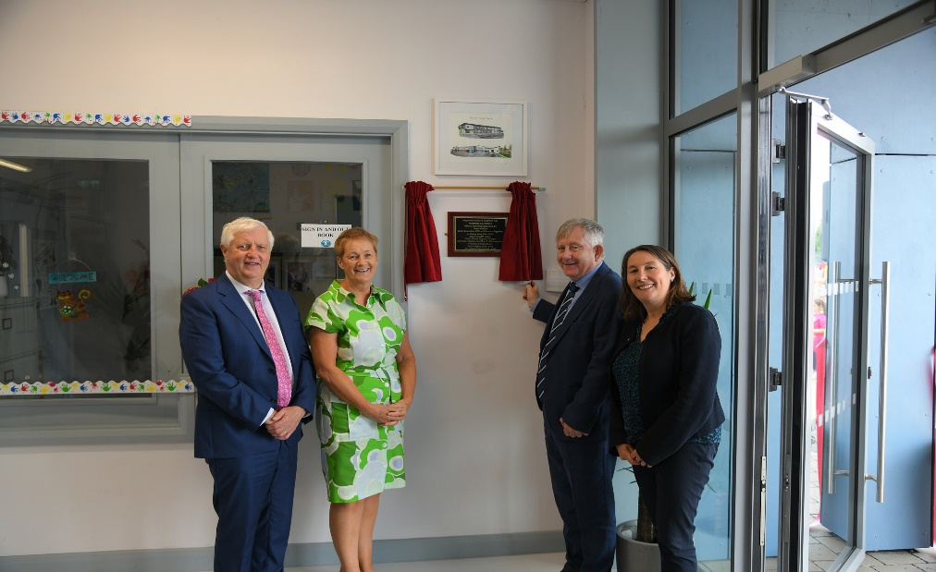
Principal Goodbye.
From 2008 to 2023, I have had the great privilege of being Principal of Maynooth Educate Together NS. Over that time, as the school has grown, I have met and worked with wonderful pupils, parents, teachers, and Boards of Management. Our pupils have been, and continue to be talented, energetic and inspiring young people, and our parent body have always been hugely supportive of myself and of the school staff. Our teachers are hugely committed to their duty as educators, and their commitment to continuous professional development ensures that they are equipped to provide a child-centered education to all pupils. Our Boards of Management have been instrumental in providing resources and of course, our newly-built modern school building.
I thank you for your support of me and the school. I thank you for your good wishes to me on my retirement. I look forward to watching from afar the future growth and development of the school. I wish you all well and hope that life is good to you all. Go n-éirí libh. Slán agus beannacht. Marie.

